**­5306 Assignment 1 (Team – 5)**

**Honor Code:**

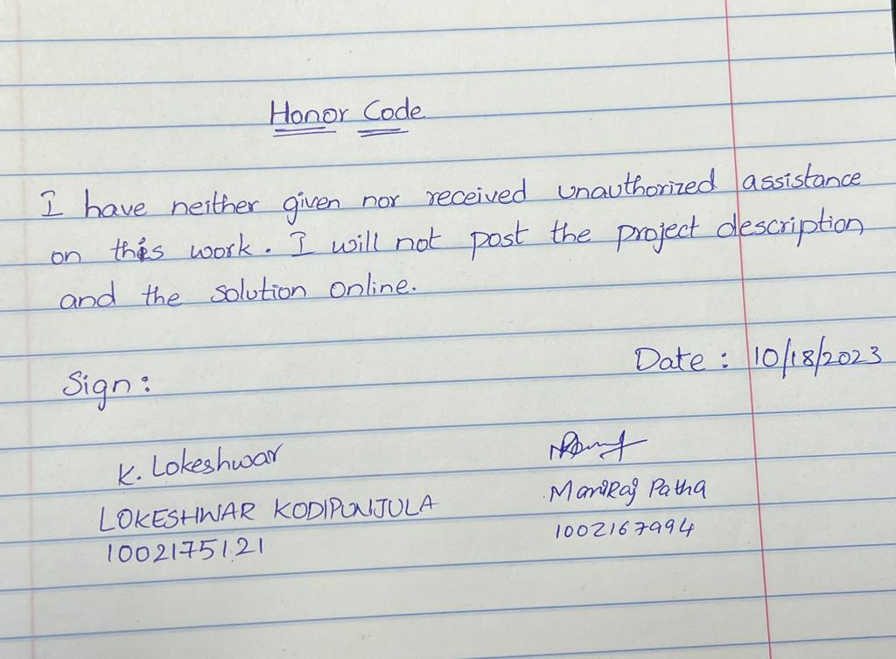

**Question 1: PYTHON**

**Name: Lokeshwar Kodipunjula**

**Student ID: 1002175121**

To package a Python application within a Docker image, the procedure entailed developing a Dockerfile. Then a container was launched by using an image that was created using the Dockerfile. The Python program running inside the container was easily integrated with the database setup created in the next phase. Every command that was run during this procedure was meticulously documented with screenshots of the corresponding results, thereby

illuminating the entire operation.

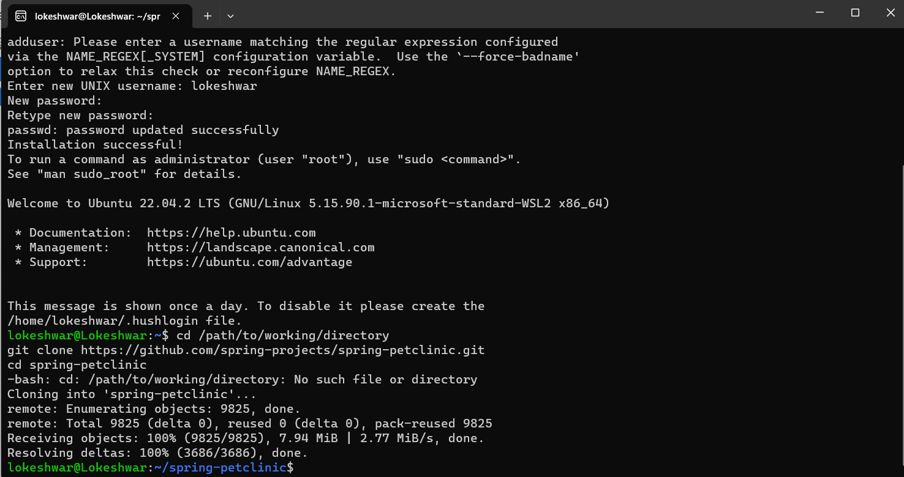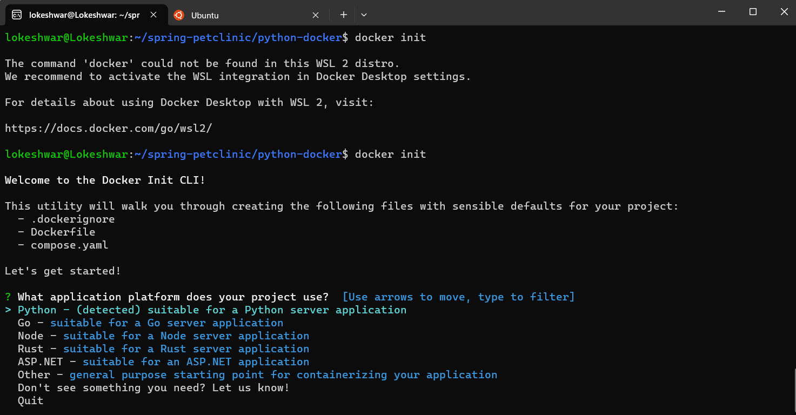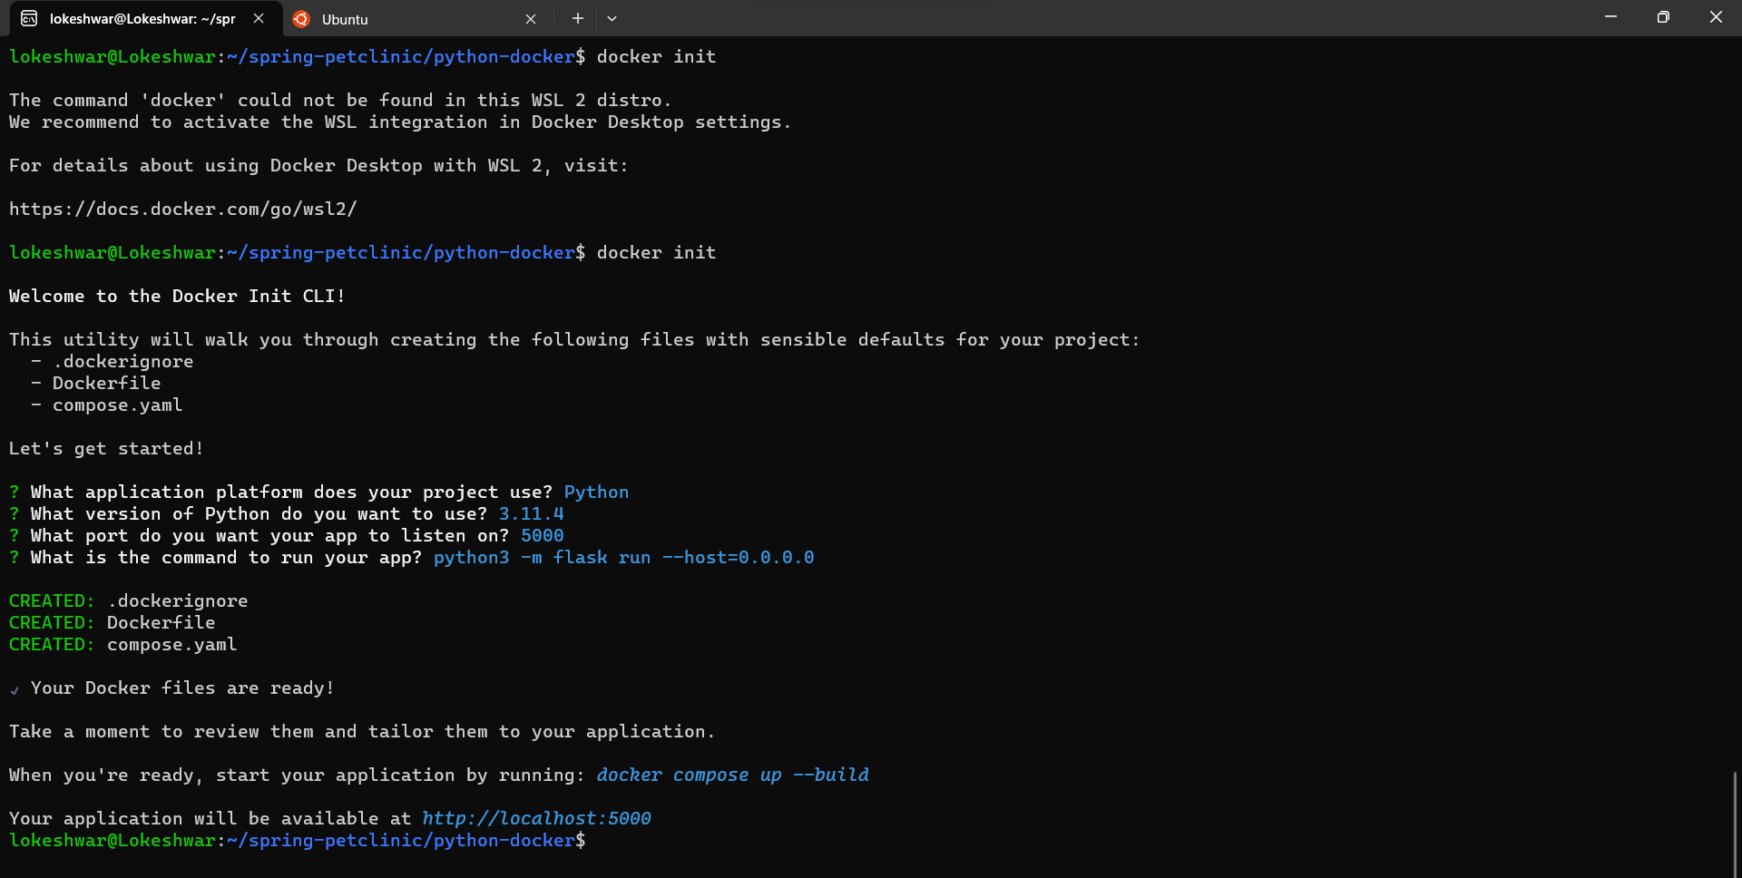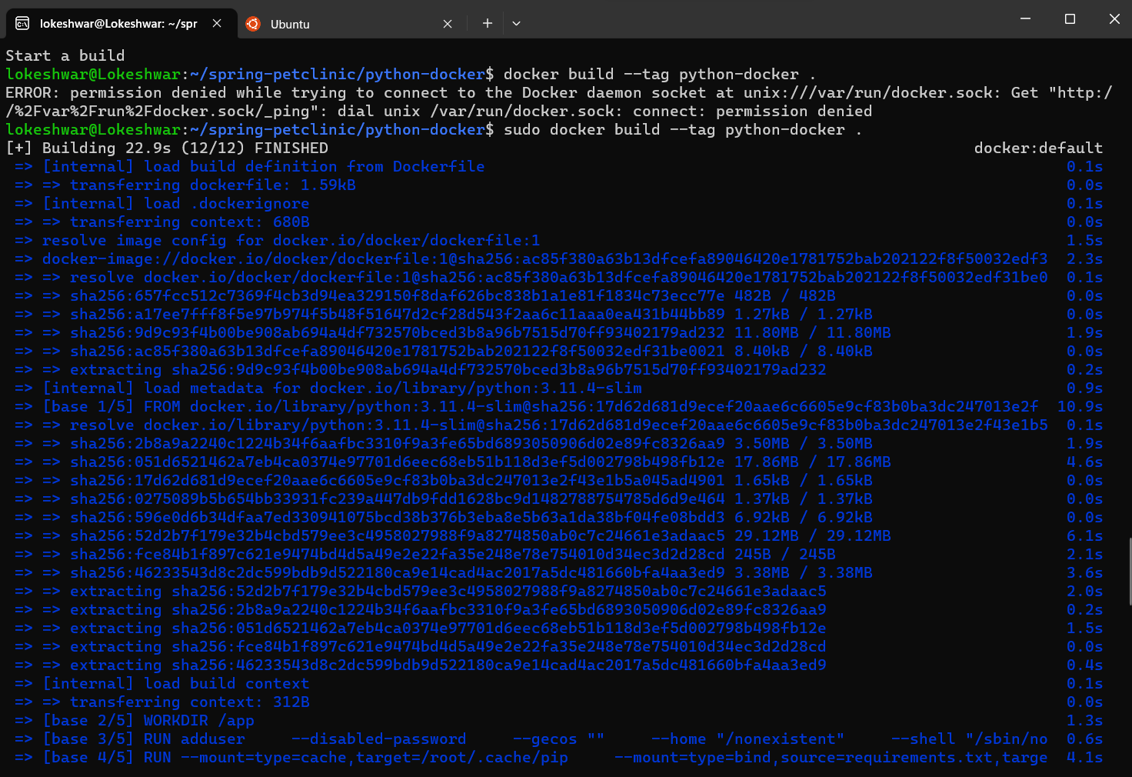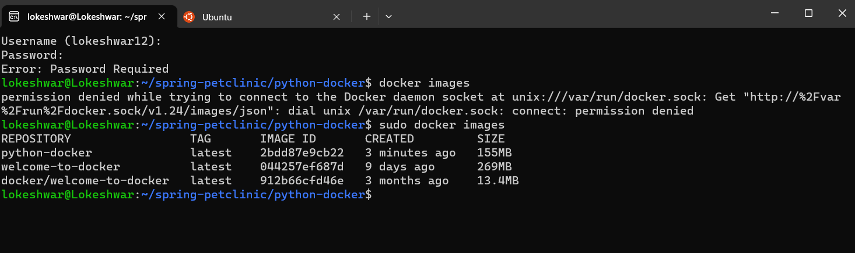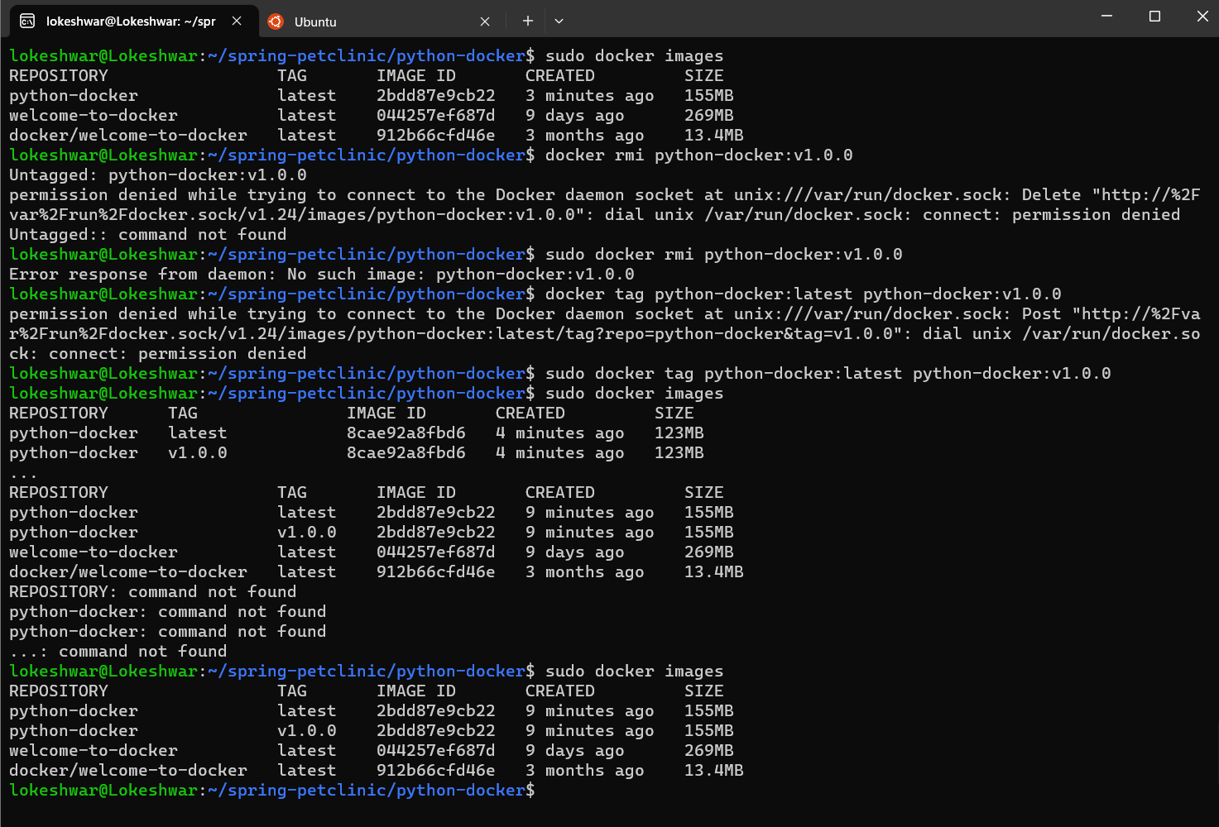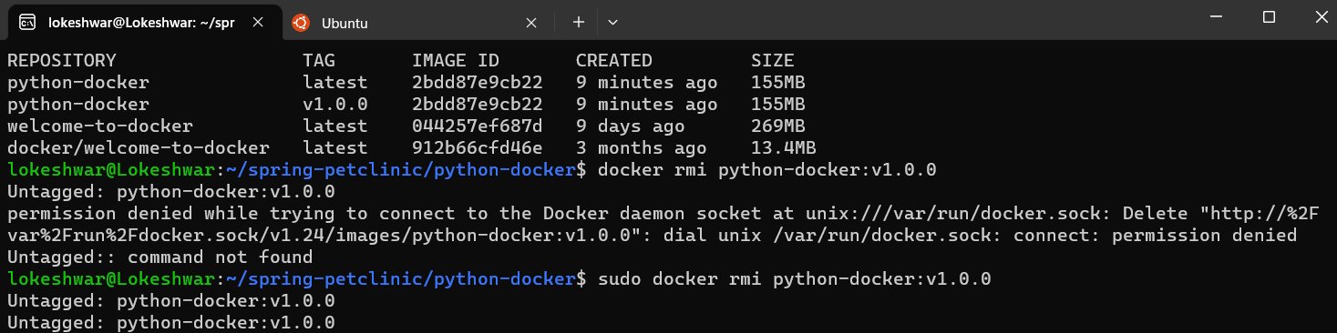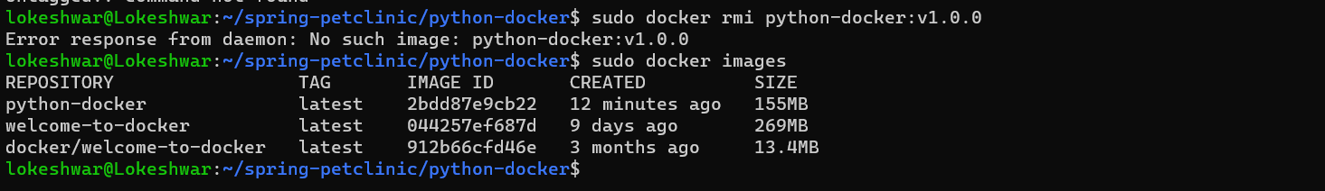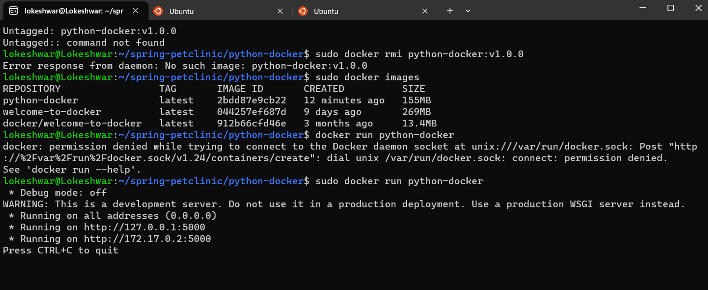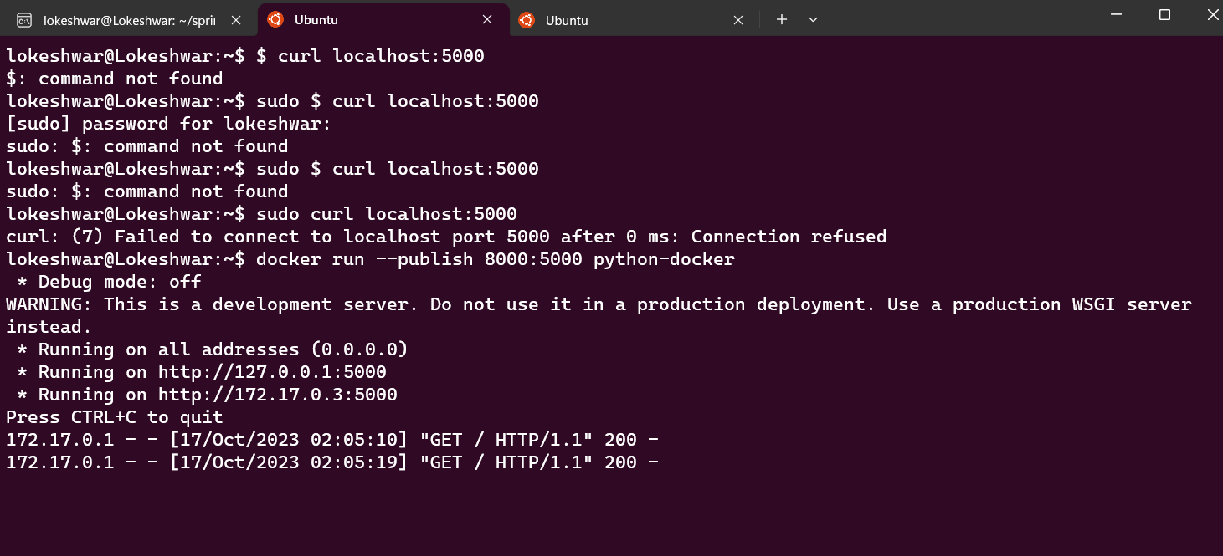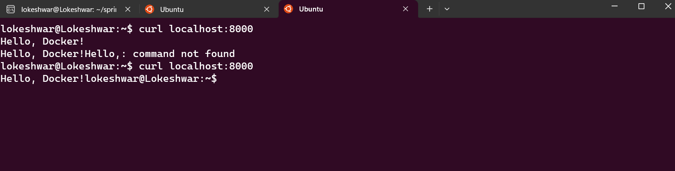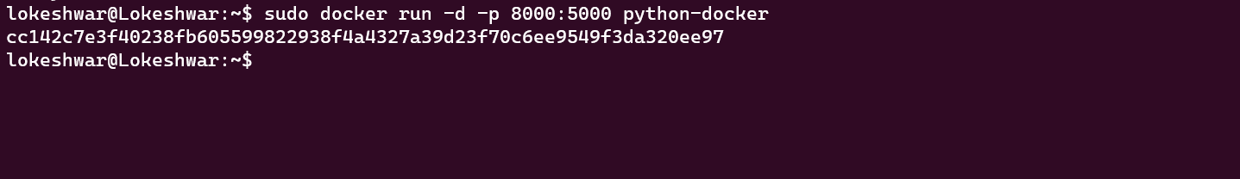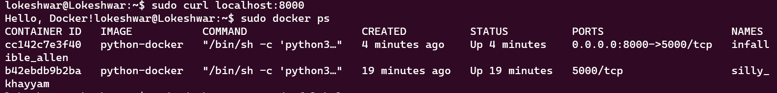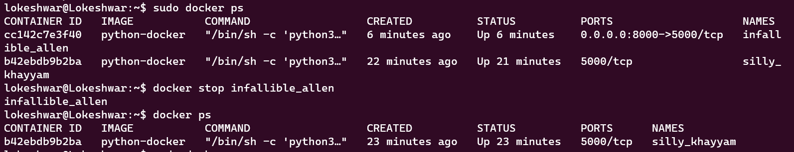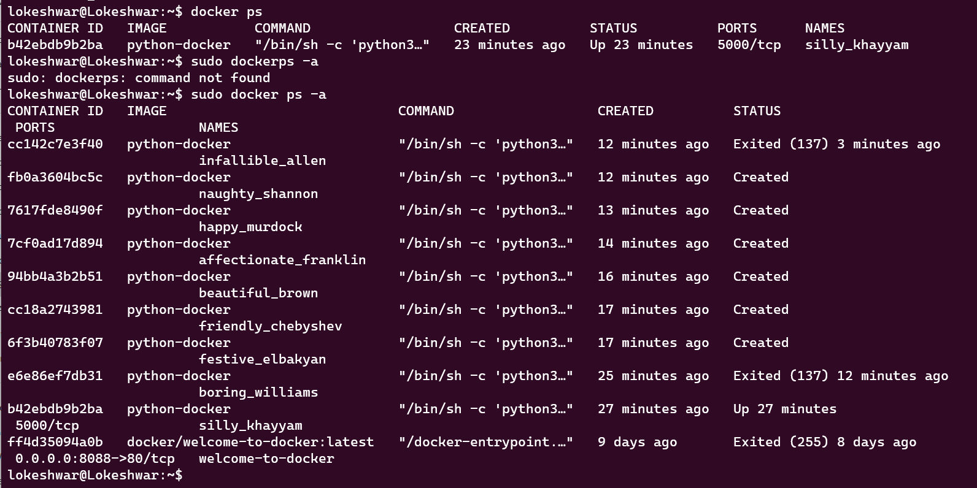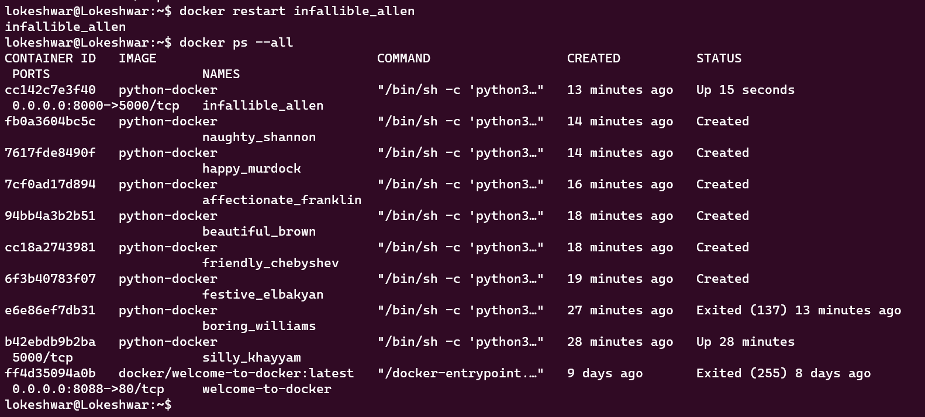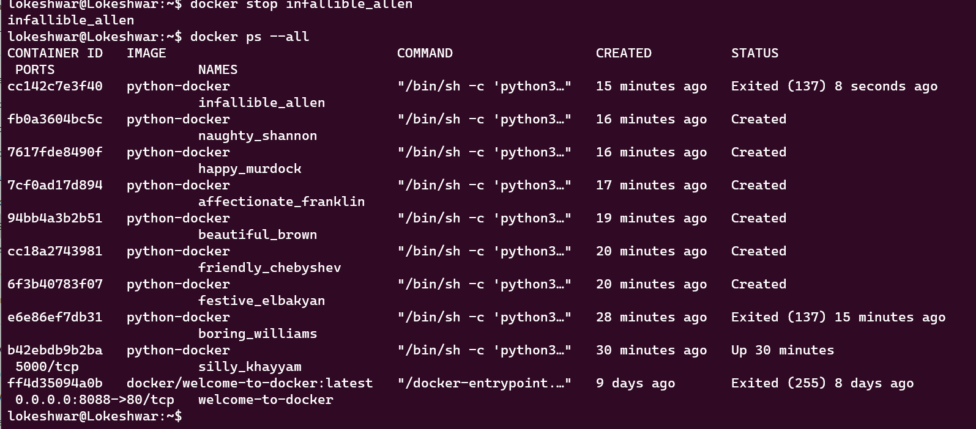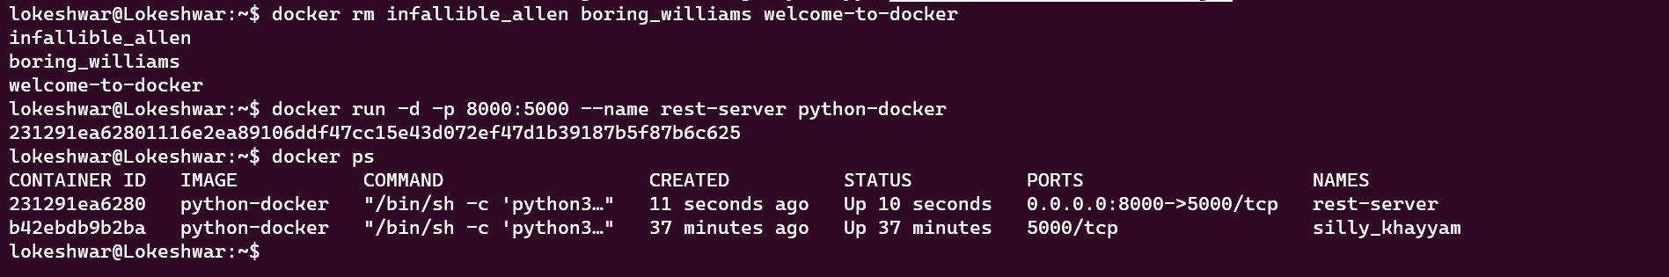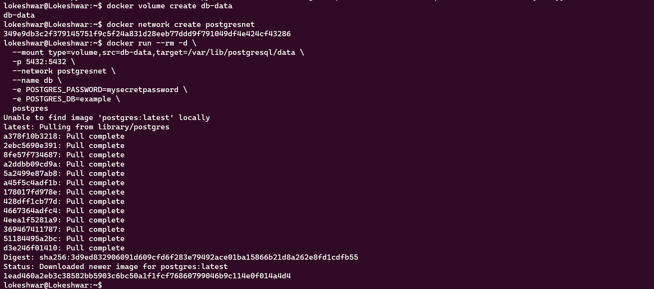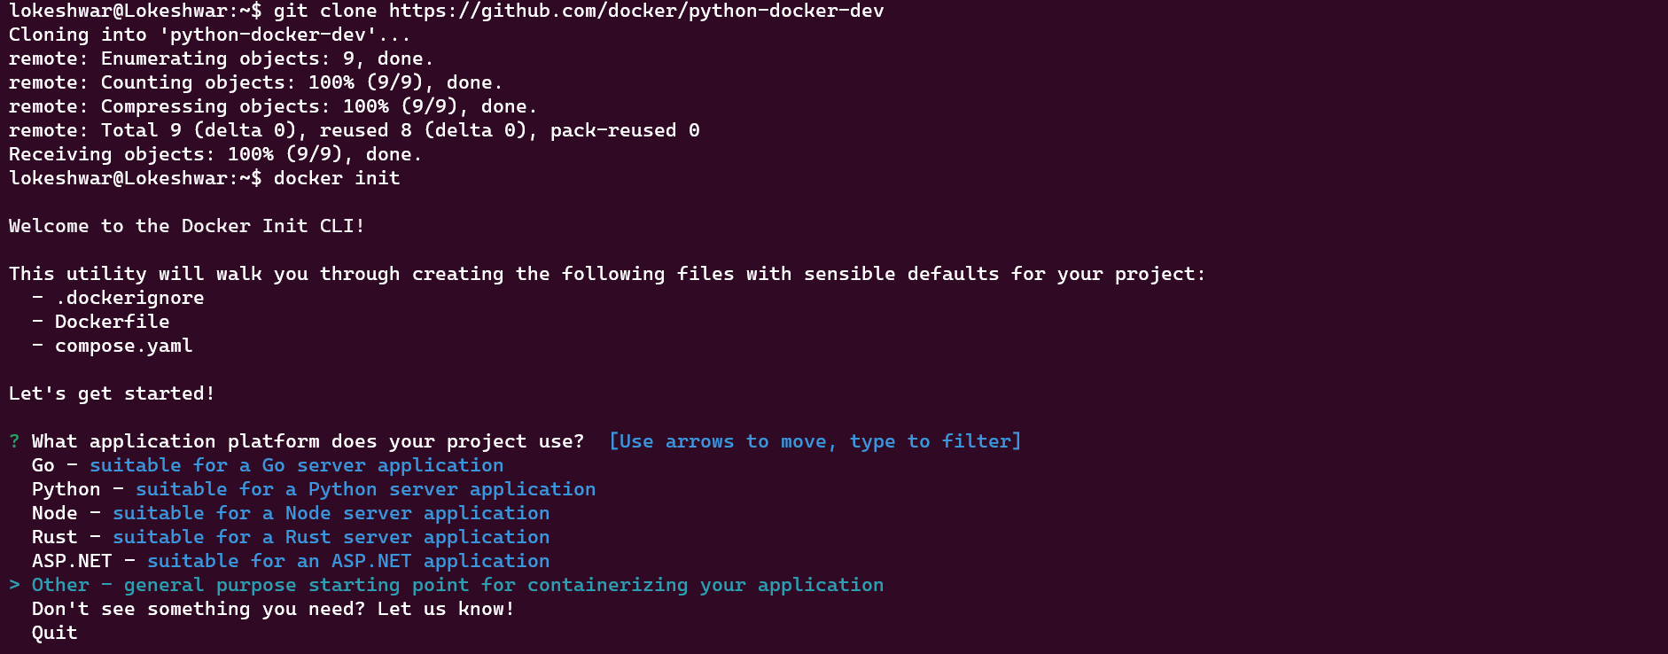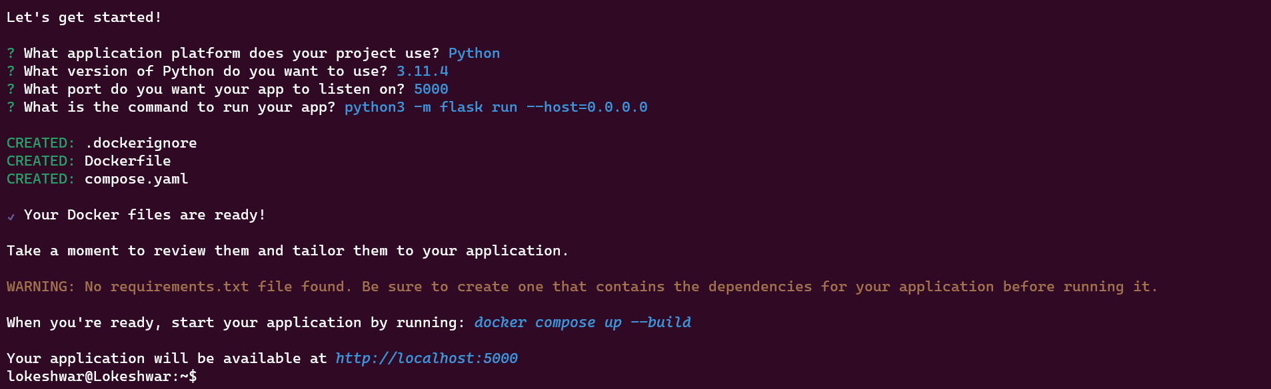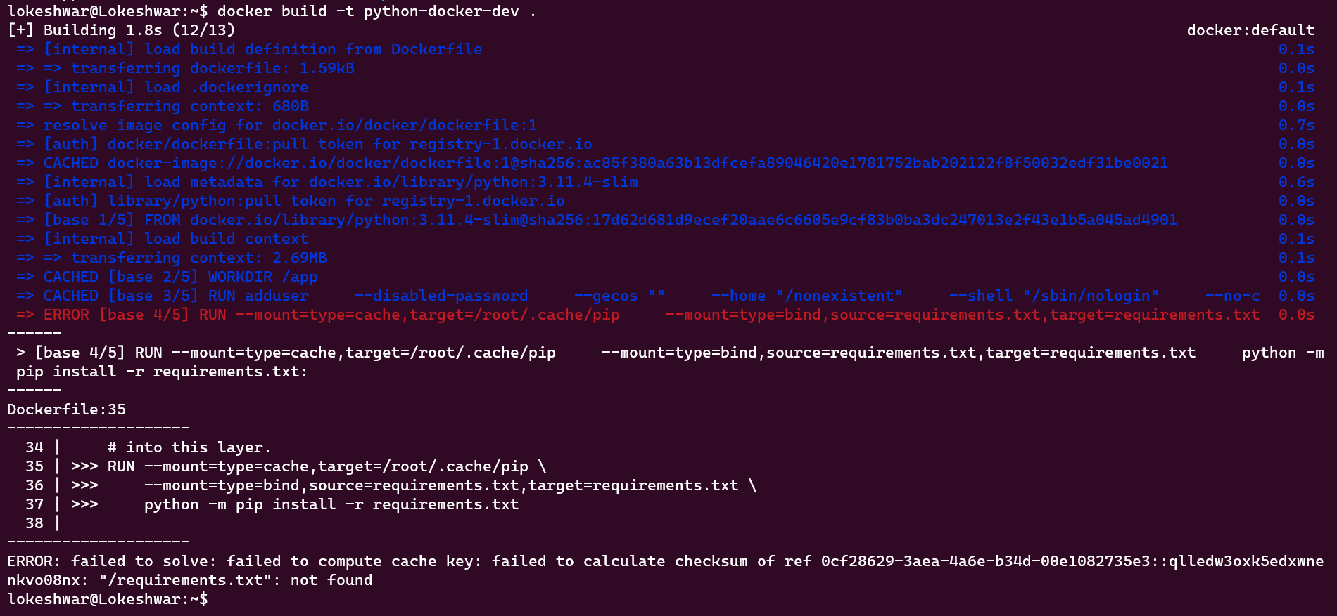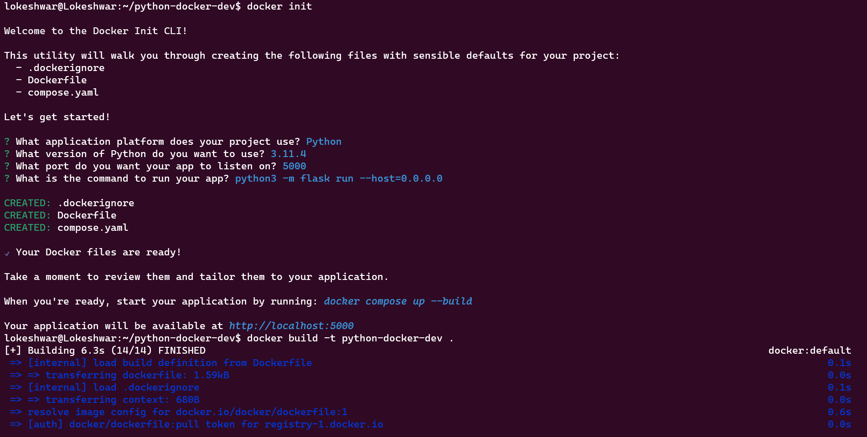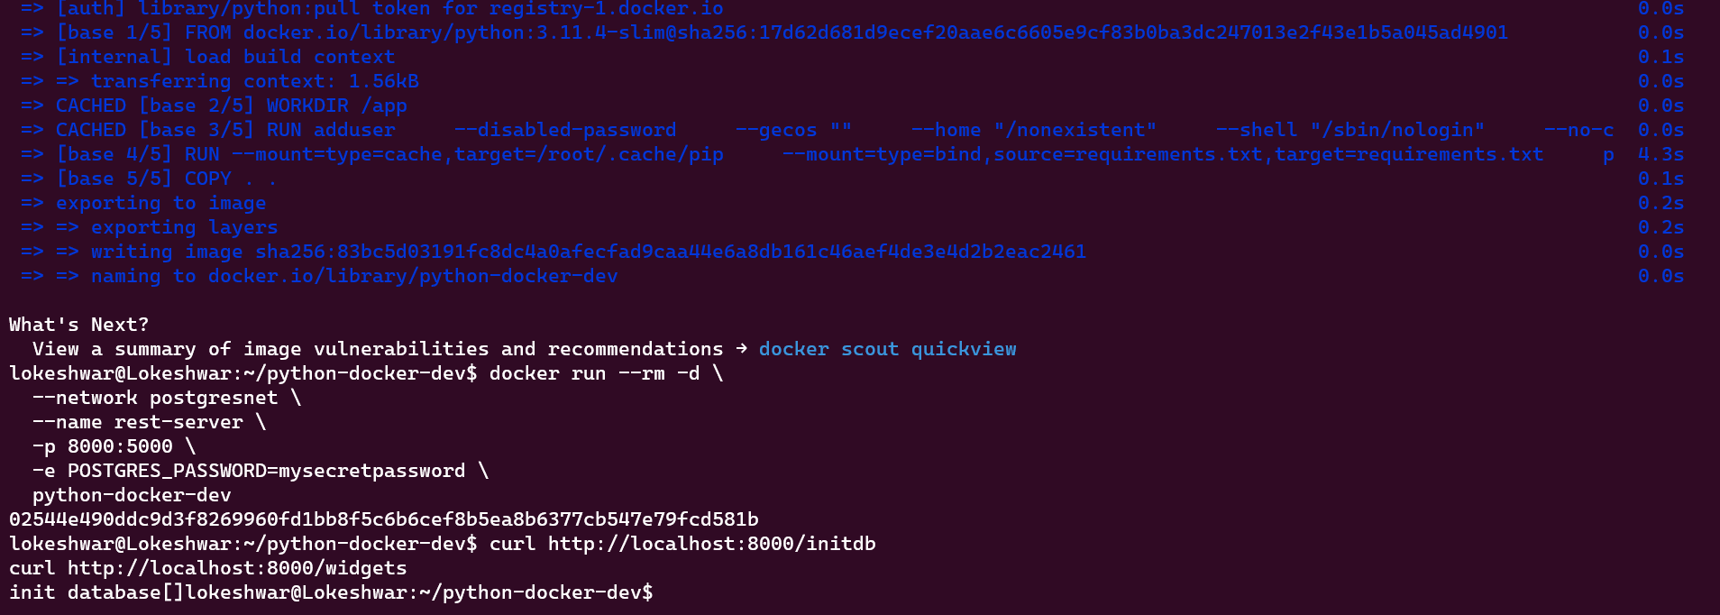

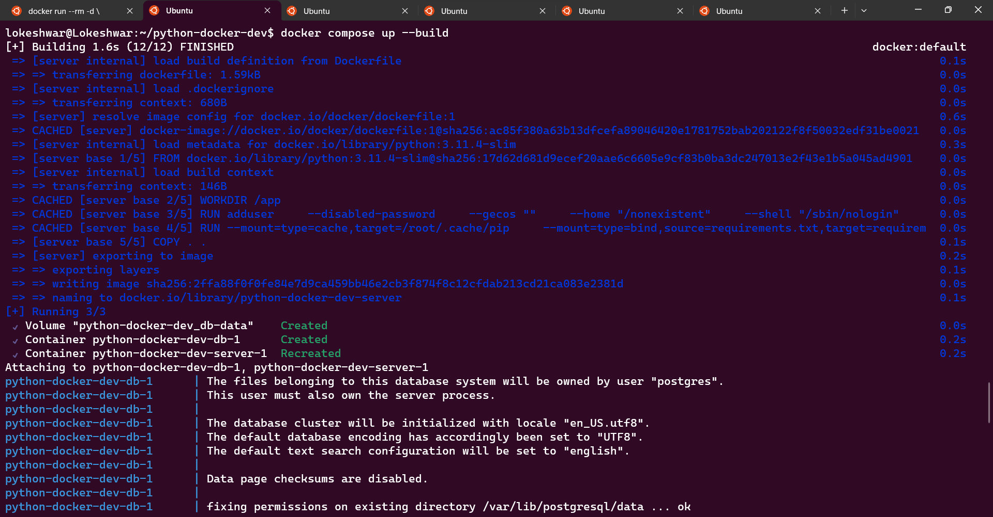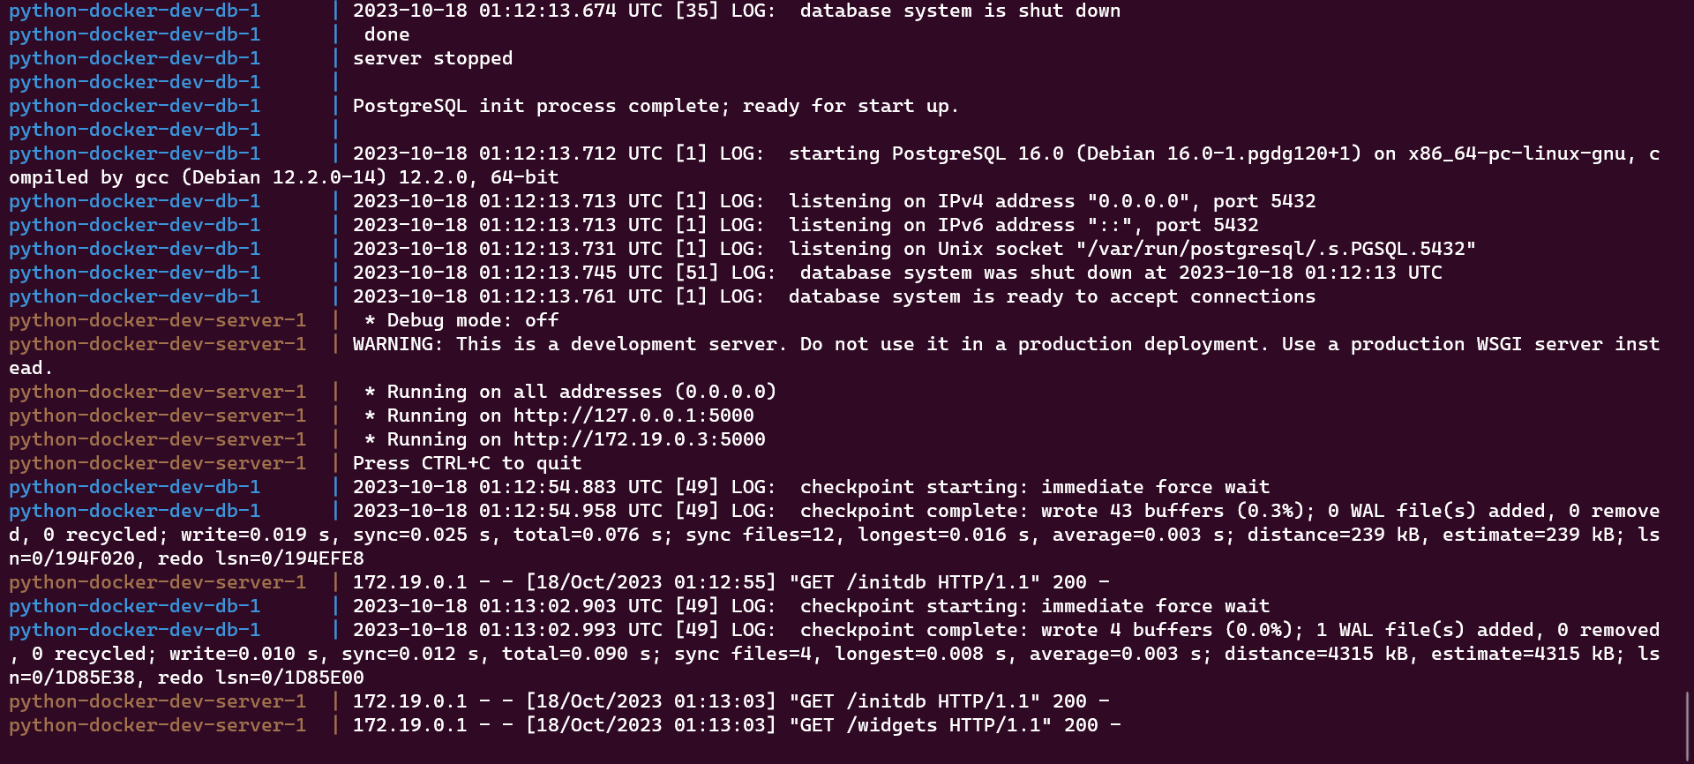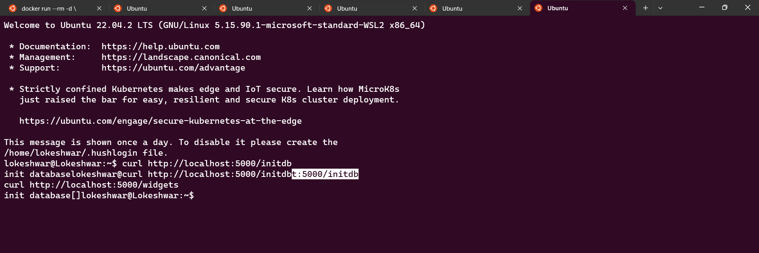

**Question 2: PYTHON**

From the given guide we had executed the following commands

**Name: Lokeshwar Kodipunjula**

**Student ID: 1002175121**

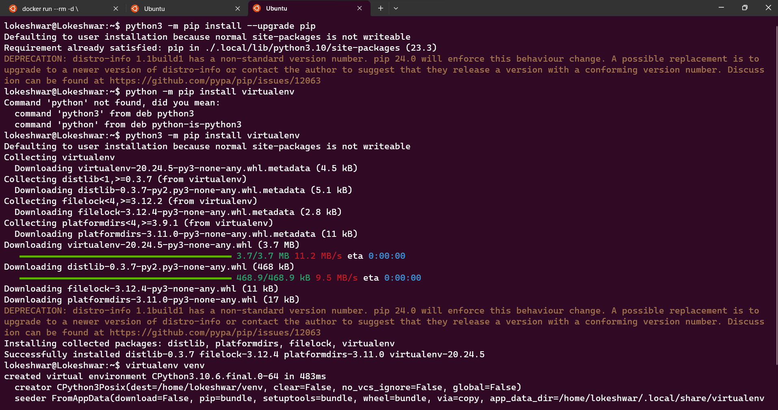

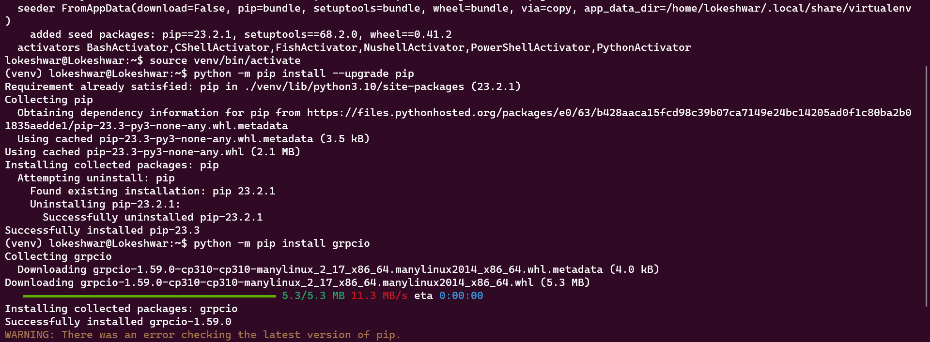

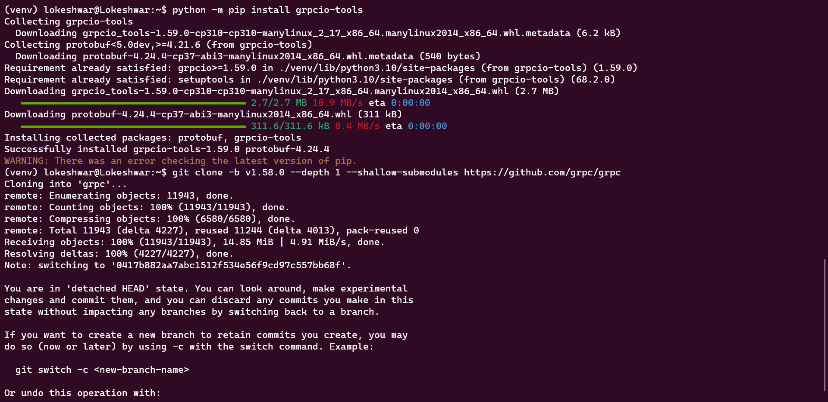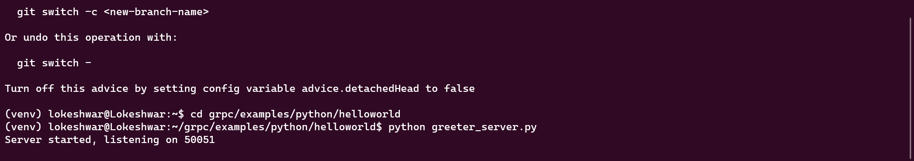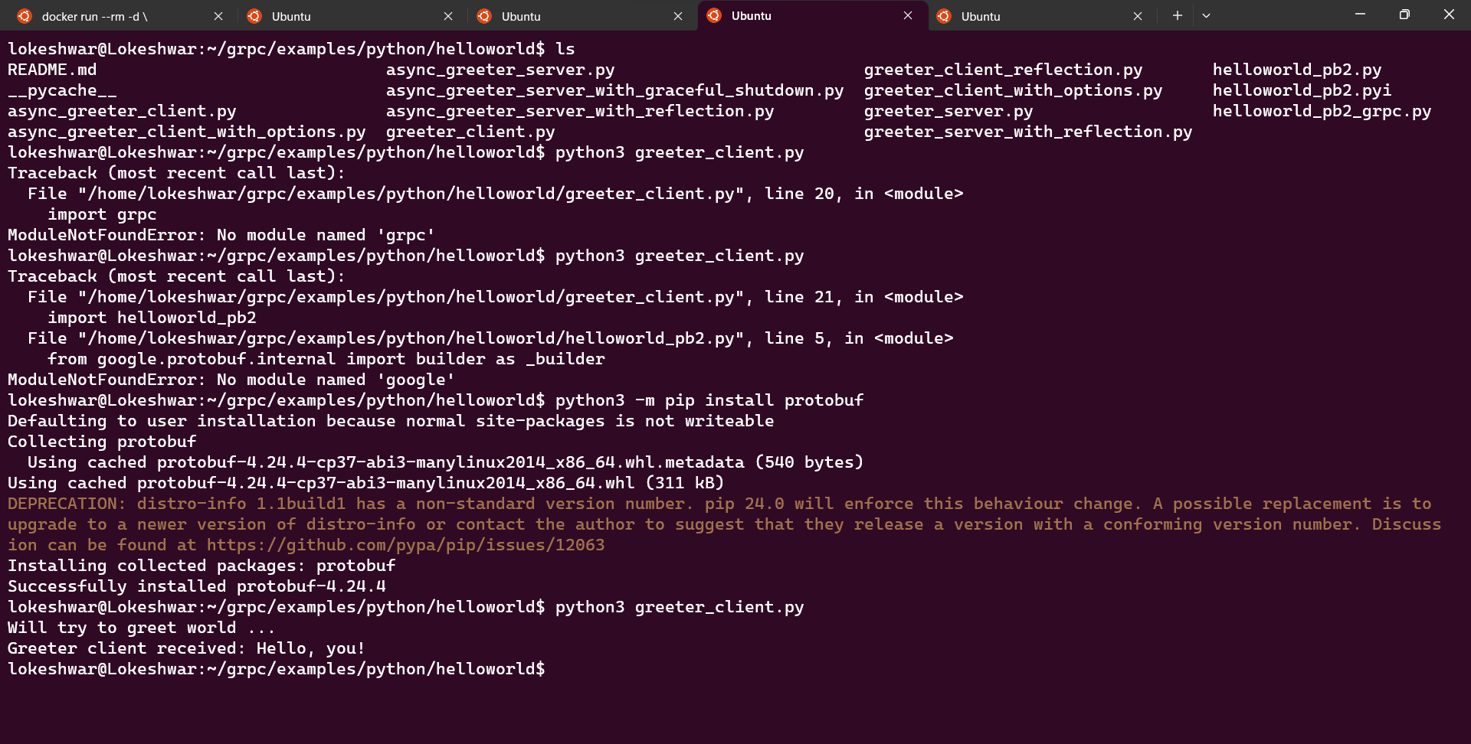





**Question 1: JAVA**

**Name: Maniraj Patha**

**Student ID: 1002167994**

Creating a new Dockerfile, meticulously tailored with the necessary instructions for building a Java image. Once the Dockerfile is set, you will proceed to launch the newly built image as a container. In addition to this, you will establish a local development environment designed to seamlessly connect a database to the container. Lastly, you will leverage the power of Docker Compose to orchestrate and run the Spring Boot application, integrating all the necessary components within a cohesive containerized ecosystem. This comprehensive guide will equip you with the essential skills to proficiently deploy, manage, and streamline Spring Boot applications within Docker containers using Docker Compose.

**Sample application**

**Create a Dockerfile for Java**

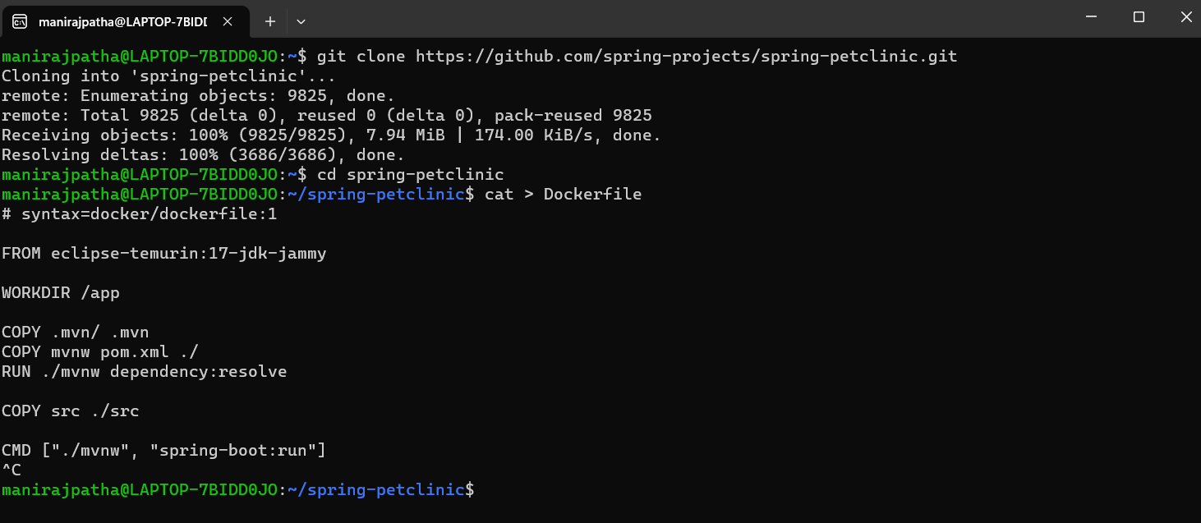

**Create a .dockerignore file**



**Build an Image**

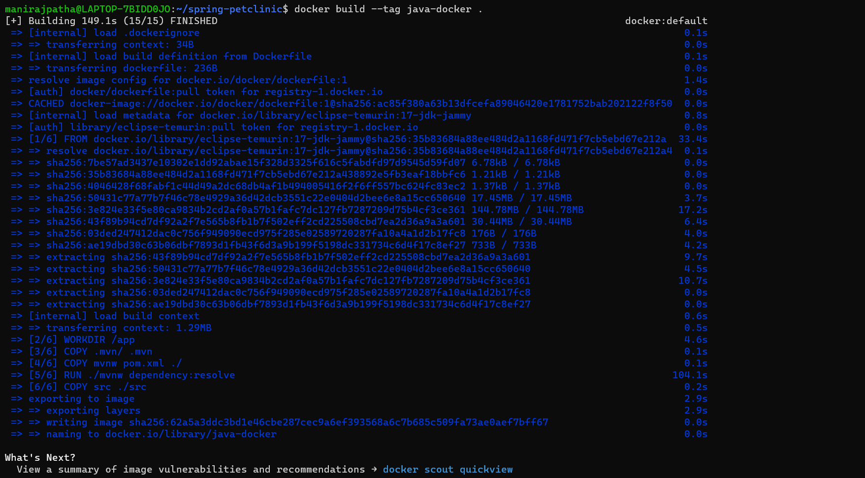

**View local images**

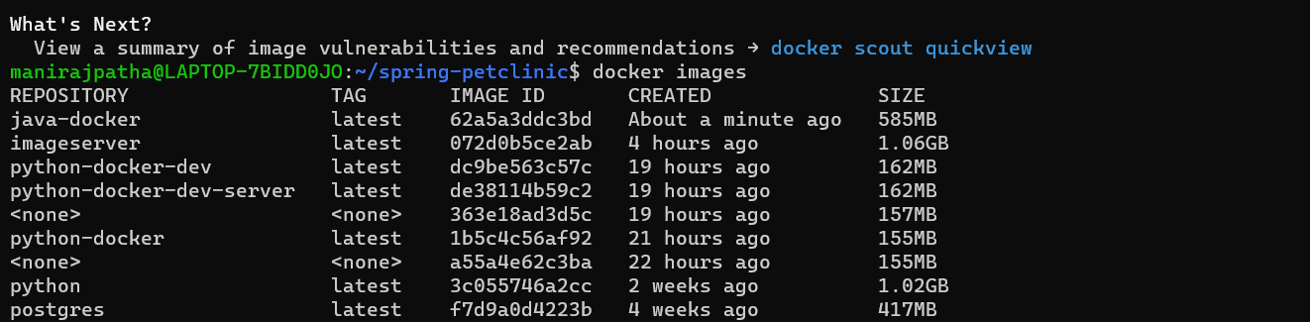

**Tag Images**

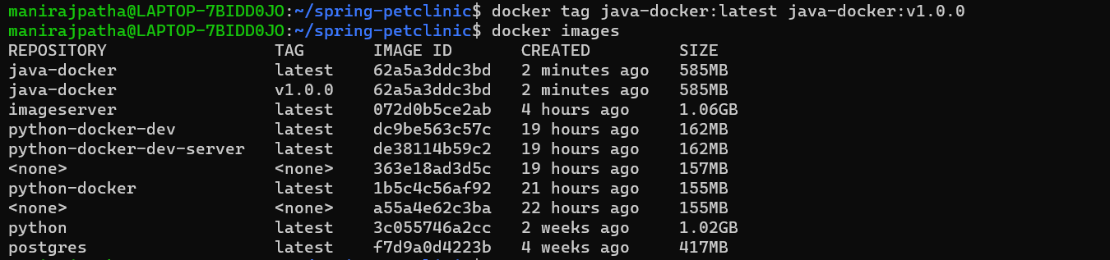

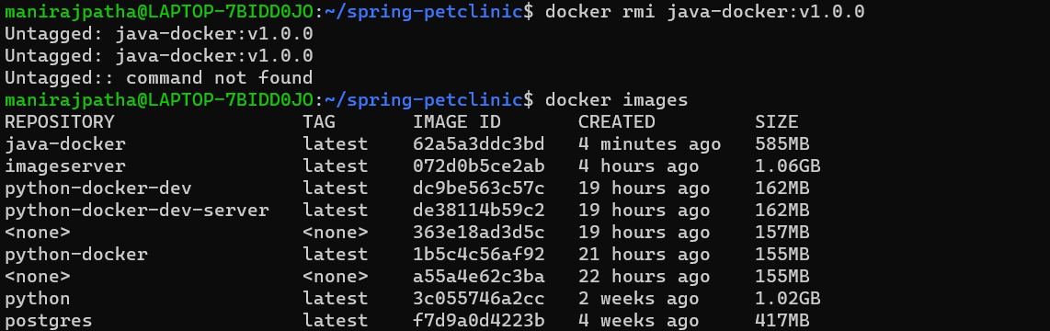

**Running image as a container**

**Trying to access application as-is**





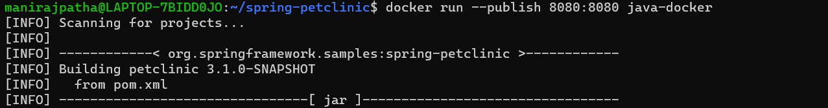

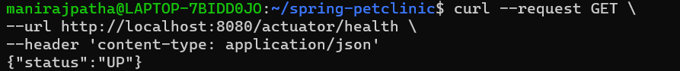

**Detached mode**

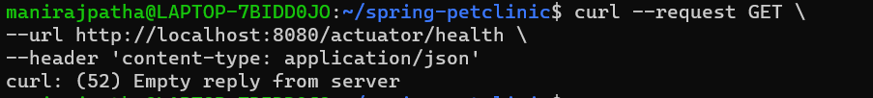



**List Containers**

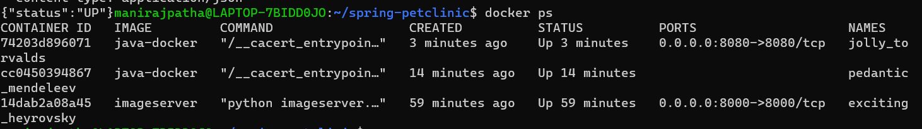



**Start, stop and name containers**

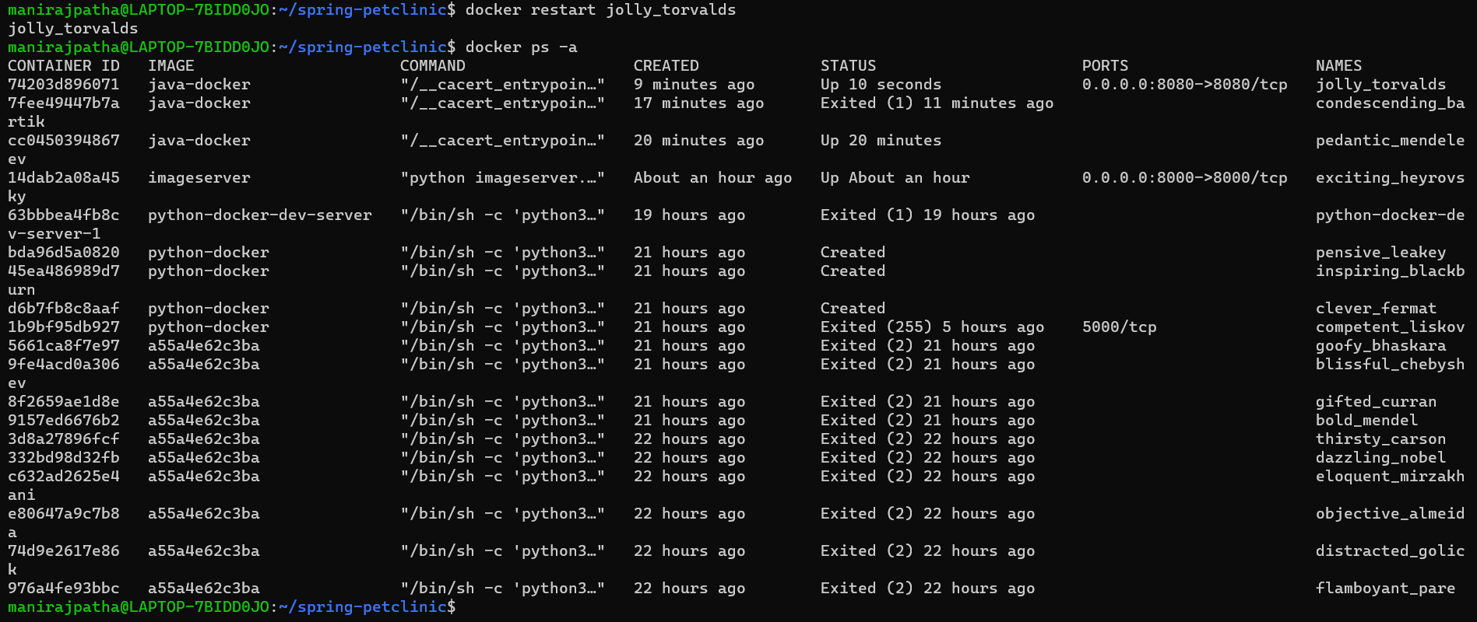

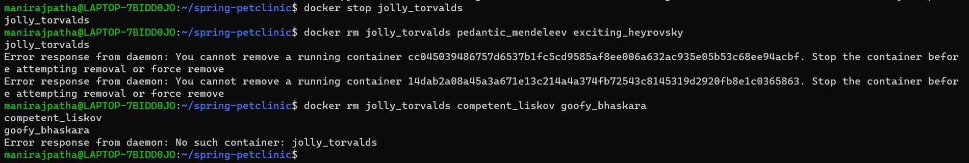

**Developing app**

**Run a database in a container**

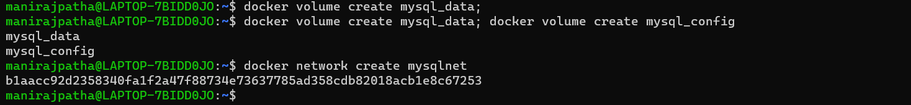

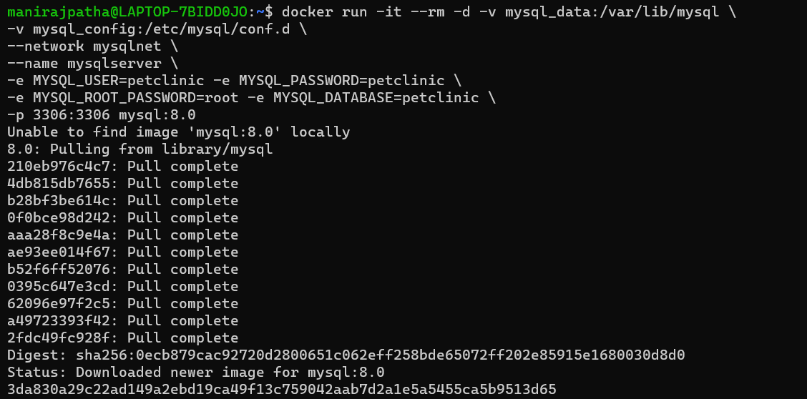

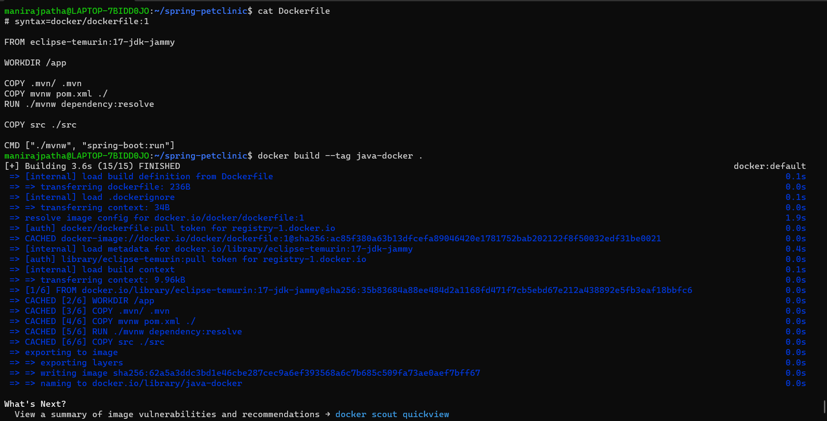

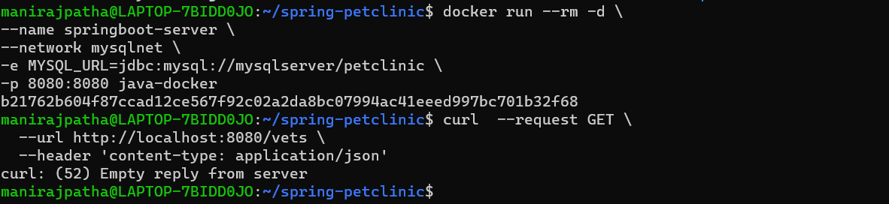

**Multistage Dockerfile for Development**

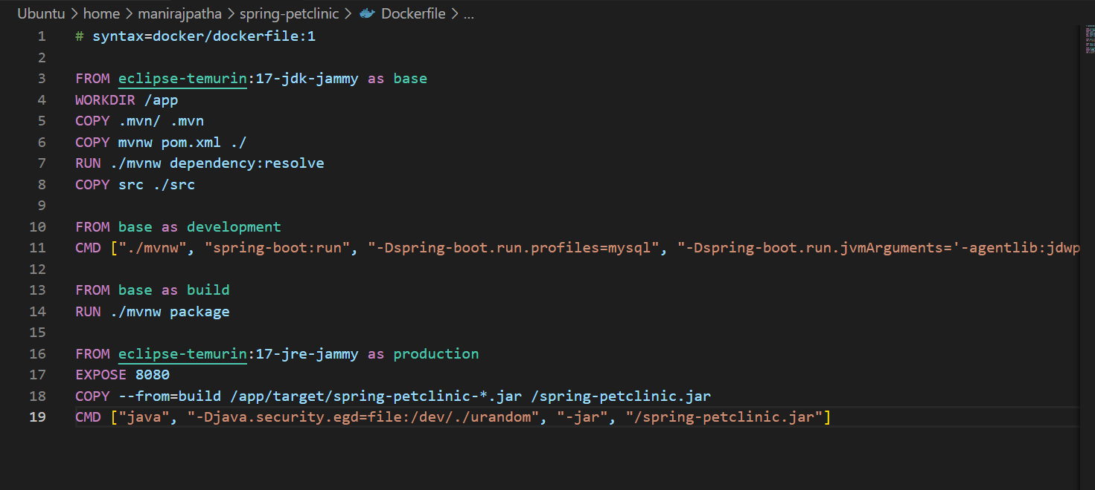

**Use compose to develop locally**

**File created in petclinic**

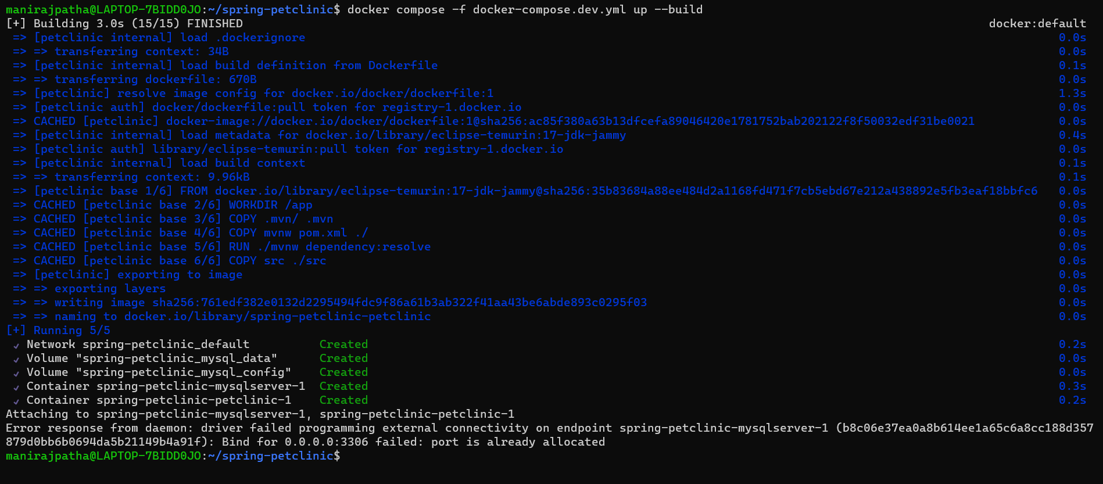

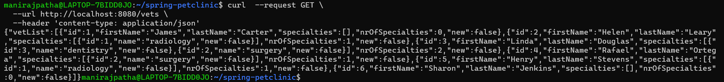

**Question -2 : JAVA**

**Name: Maniraj Patha**

**Student ID: 1002167994**

From the guide we had executed the following commands.

**Get the example code**

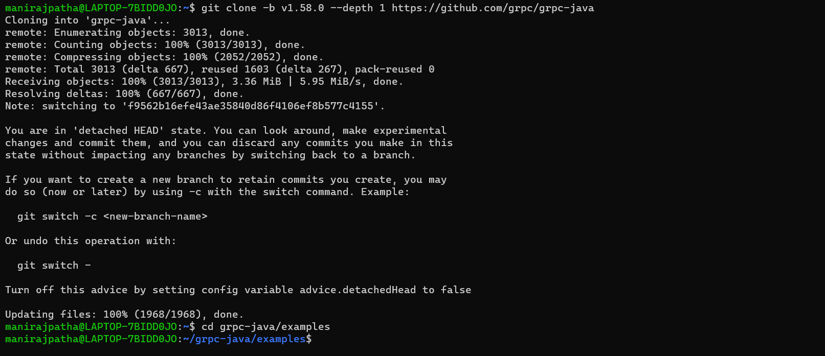

**Run the example**

**Server Side**

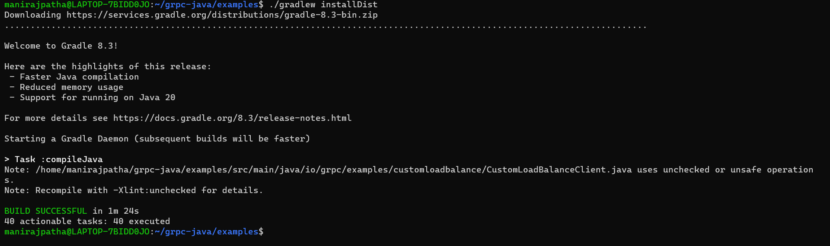



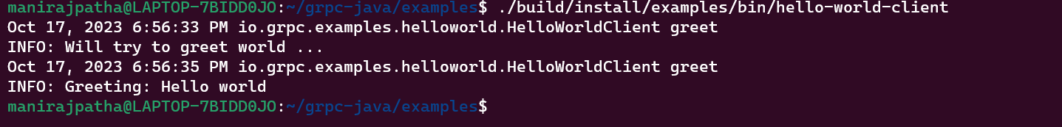

**Update the GRPC Service**

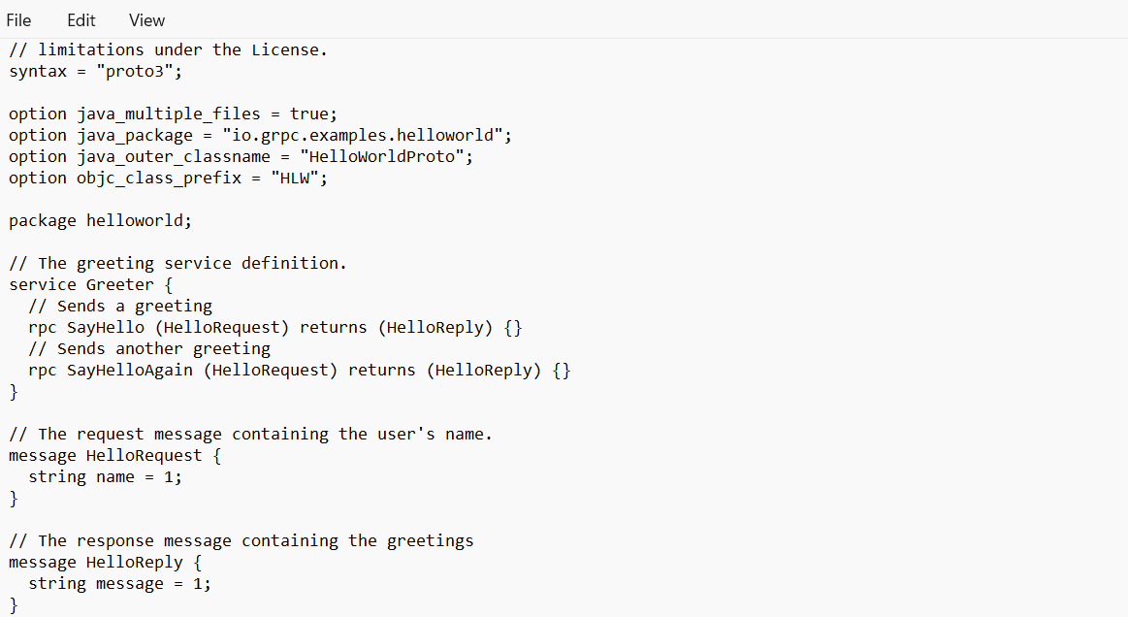

**Update the App**

**Update the server**

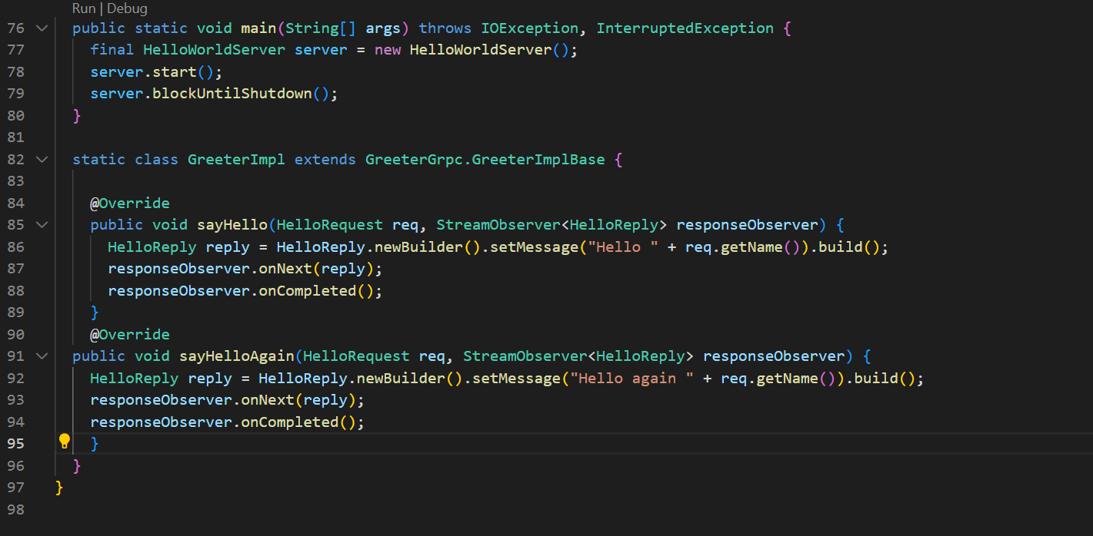

**Update the client**

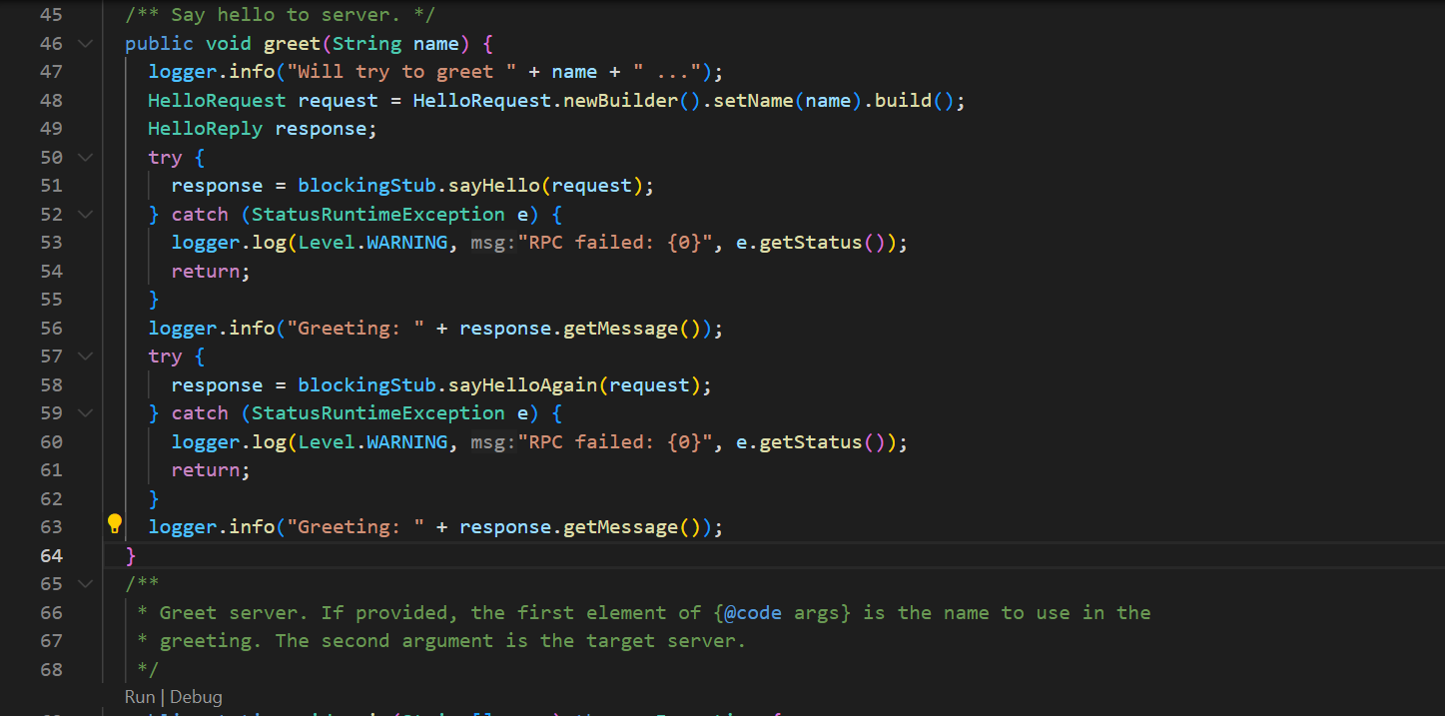

**Run the updated app**

**Compile client and server**



**Run Server**



**Run Client**

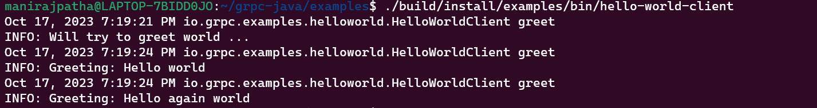

**Question 3:**

**Name: Maniraj Patha**

**ID: 1002167994**

**The server has been created by Maniraj Patha**

**Server:**

**Command: docker build -t imageserver .**

This command is used to build a Docker image based on the instructions provided in the Docker file. The resulting image is then tagged with the name “imageserver” for easy identification and management.

In the first screenshot below we can see the image has been built.

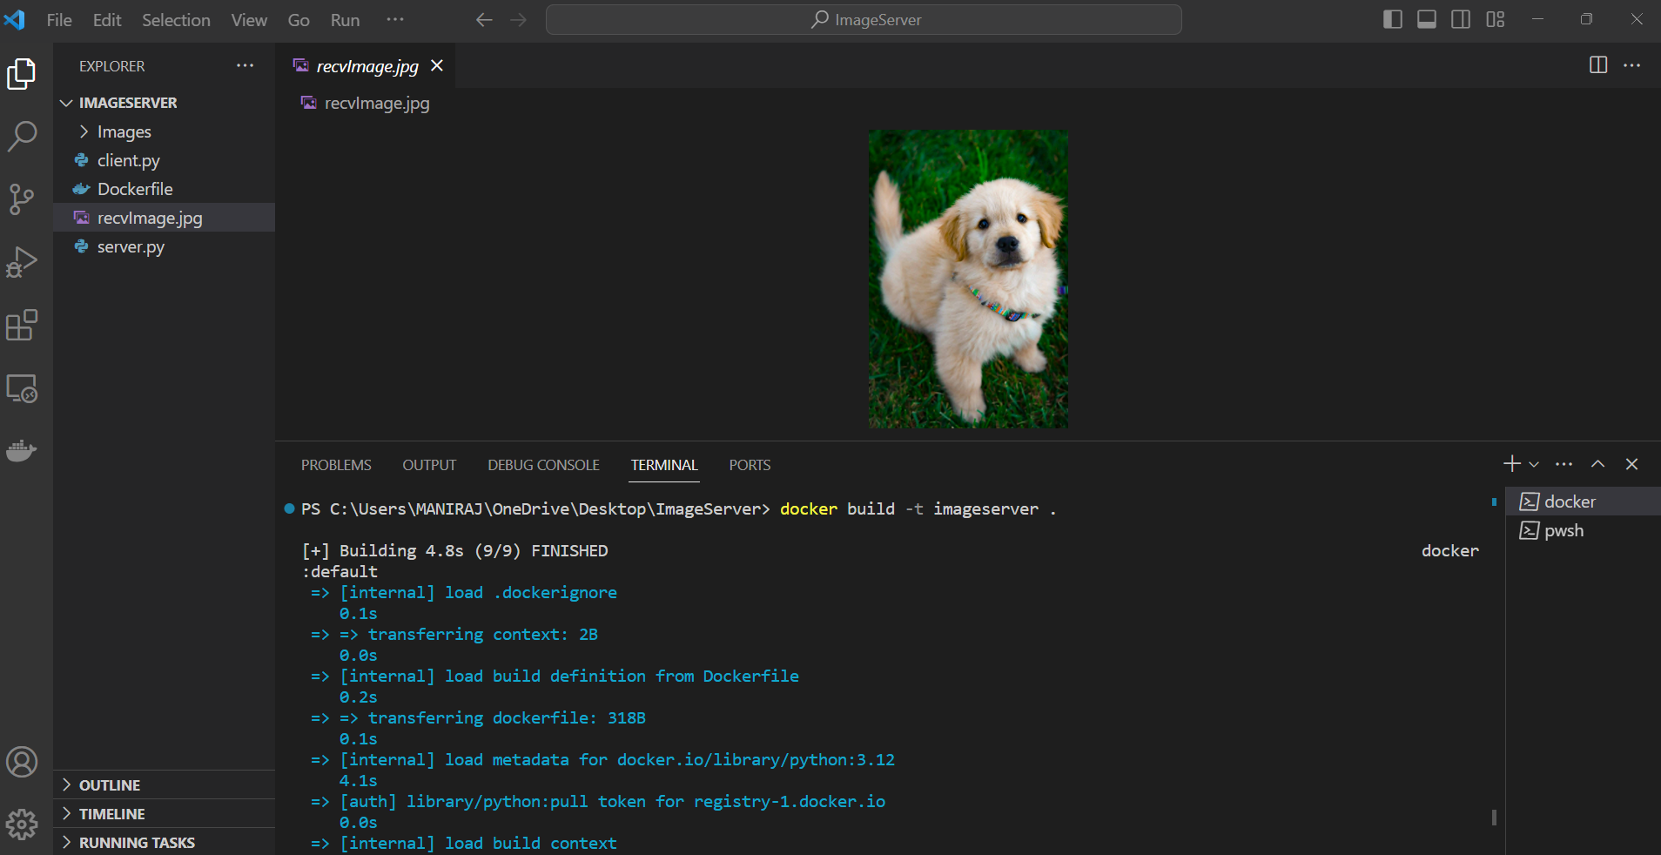

**Command: docker run -v imagepath:/Images -p 8000:8000 imageserver**

This command is used to run the server in the docker. Below screenshot shows server is in use(running).

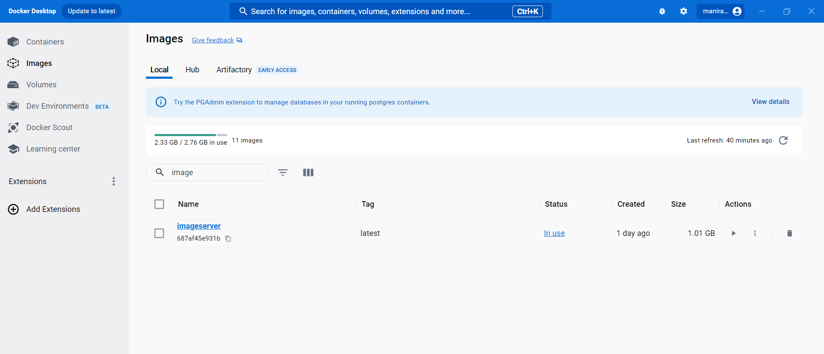

**Client:**

**Name: Lokeshwar Kodipunjula**

**Student ID: 1002175121**

**Client has created by Lokeshwar Kodipunjula**

**Command: python3 client.py**

By running this command, you are instructing the Python interpreter to execute the code within the 'client.py' script. It will ask for enter the image type, if we type ‘dog’ we will get dog image as shown in the screenshot below. Suppose, if we type ‘cat’ then cat image will be displayed in place of dog image.

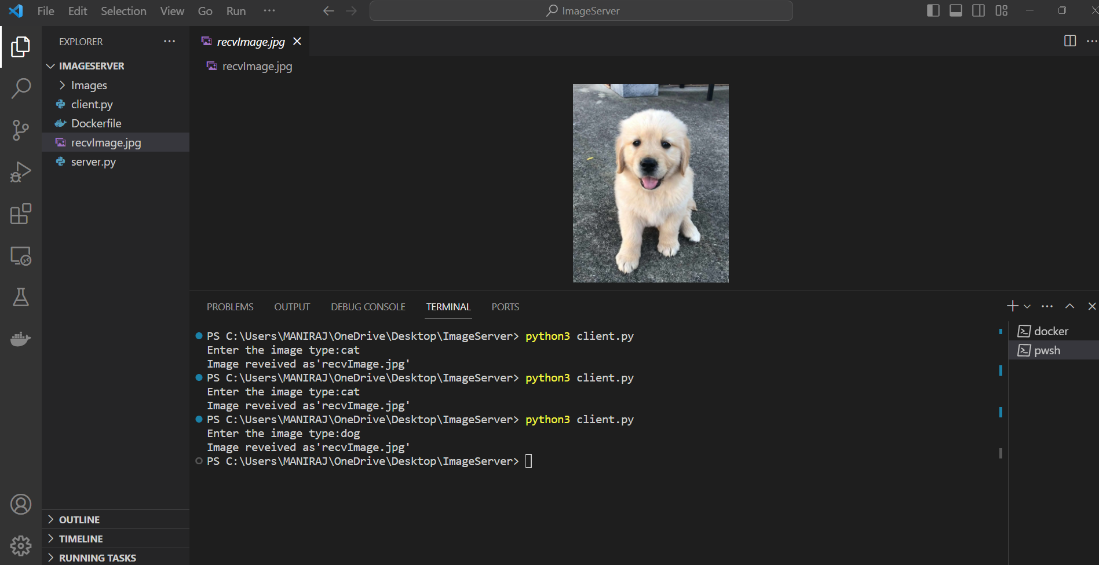

**Question 4:**

**GRPC Server**

**Name: Lokeshwar Kodipunjula**

**Student ID: 1002175121**

**GRPC Server has created by Lokeshwar Kodipunjula**

**Command: docker build -t imageserver .**

By running this command, we can build imageserver using GRPC. Screenshot below shows that server has build by using this command.

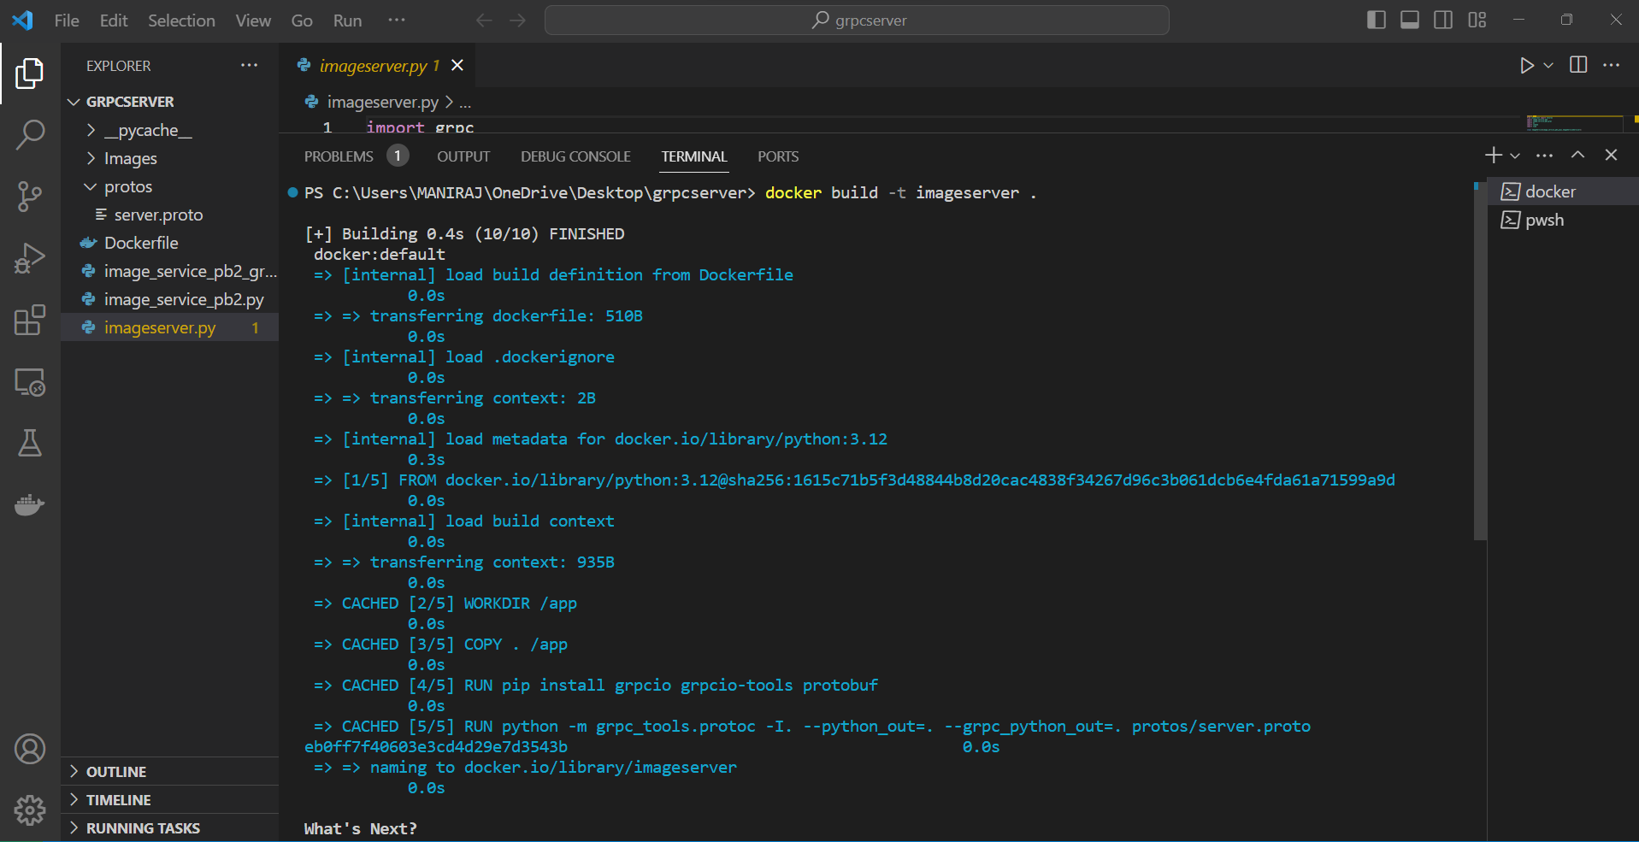

**Command: docker network create grpc-network**

By using this command, we can create a new Docker network with the name 'grpc-network'. In the below screenshot the network is created.



**Command: docker run –network grpc-network -v imagepath/Image_search//ImageServer/Images:/Images -p 8000:8000 imageserver**

By using this command, we can run the server in the docker.



**GRPC Client**

**Name: Maniraj Patha**

**ID:1002167994**

**GRPC Client has created by Maniraj Patha**

**Command: python3 imageserver.py**

We need to run this command in the GRPC client, we can retrieve the images which are stored in the GRPC server. In below screenshot we had received image from the GRPC server.

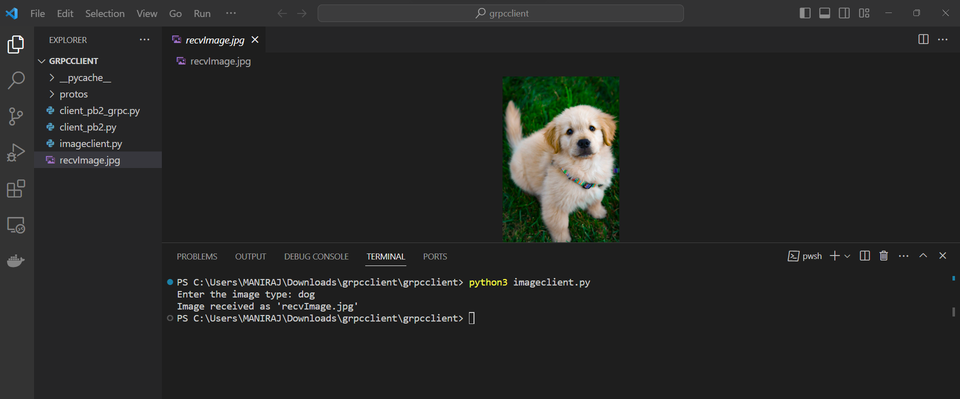

**Question 5**

Description: We have tested the server-client implementation in 5 test cases.

* First, we need to build the “imageserver” in the docker.
* We need to run the server as shown in the question 3.
* From the server we need to retrieve the images, when client has requested.
* In the first case the ‘dog’ image has received and in second case ‘cat’ has received.
* In the cases 3,4 & 5 client has requested different animal images and the images are received.
* Randomly client has requested random animal images.
* All the test cases are executed and that has shown in the below screenshots.

**Test Case 1**

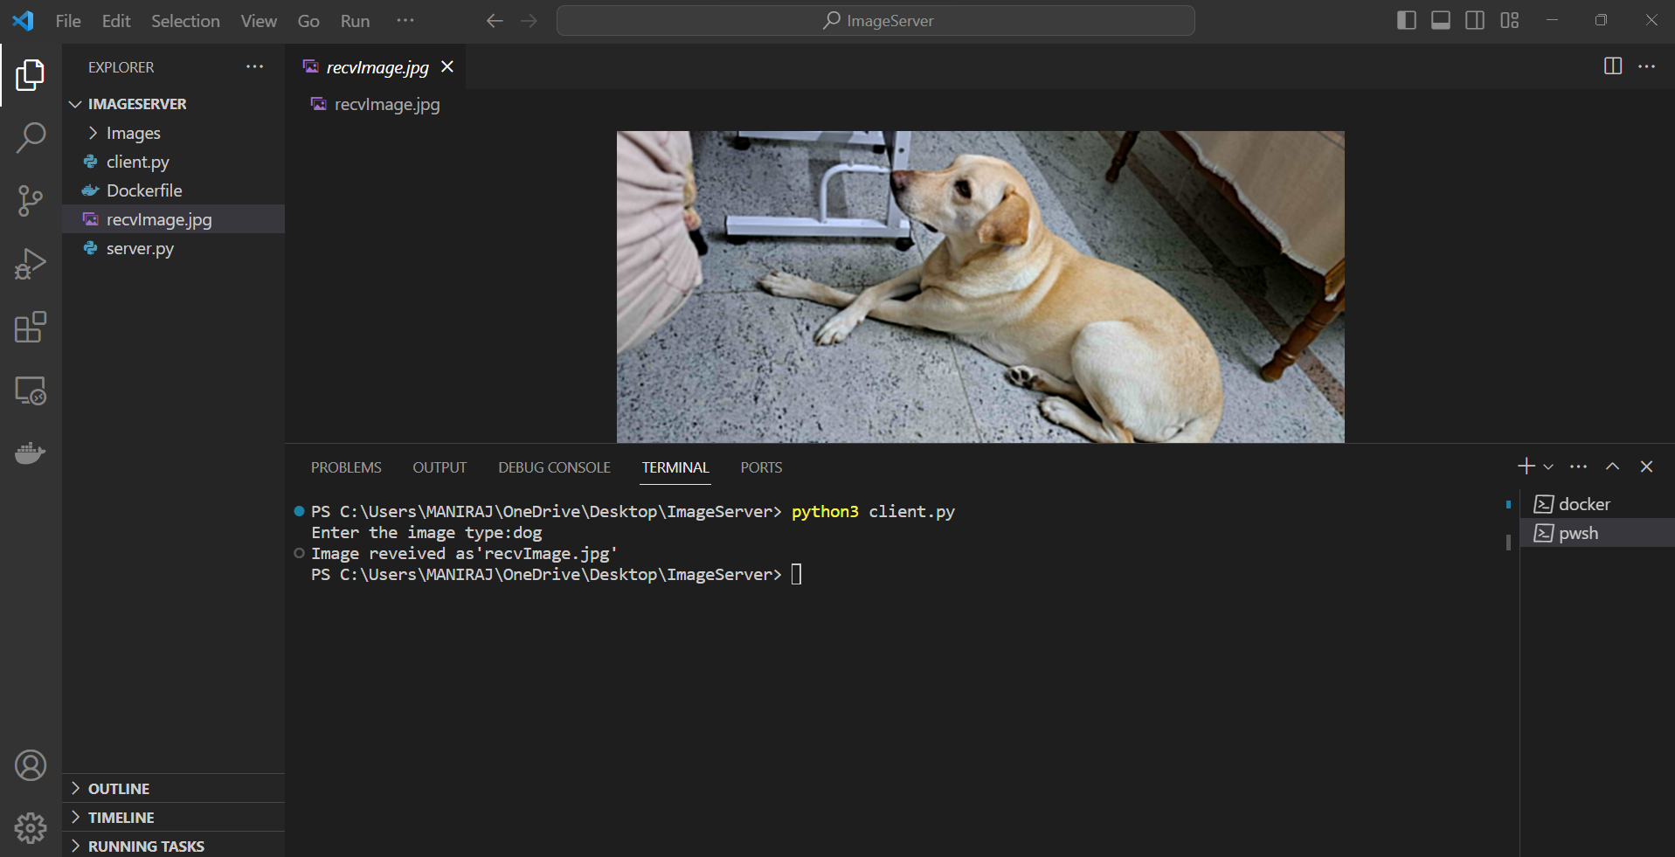

**Test case 2**

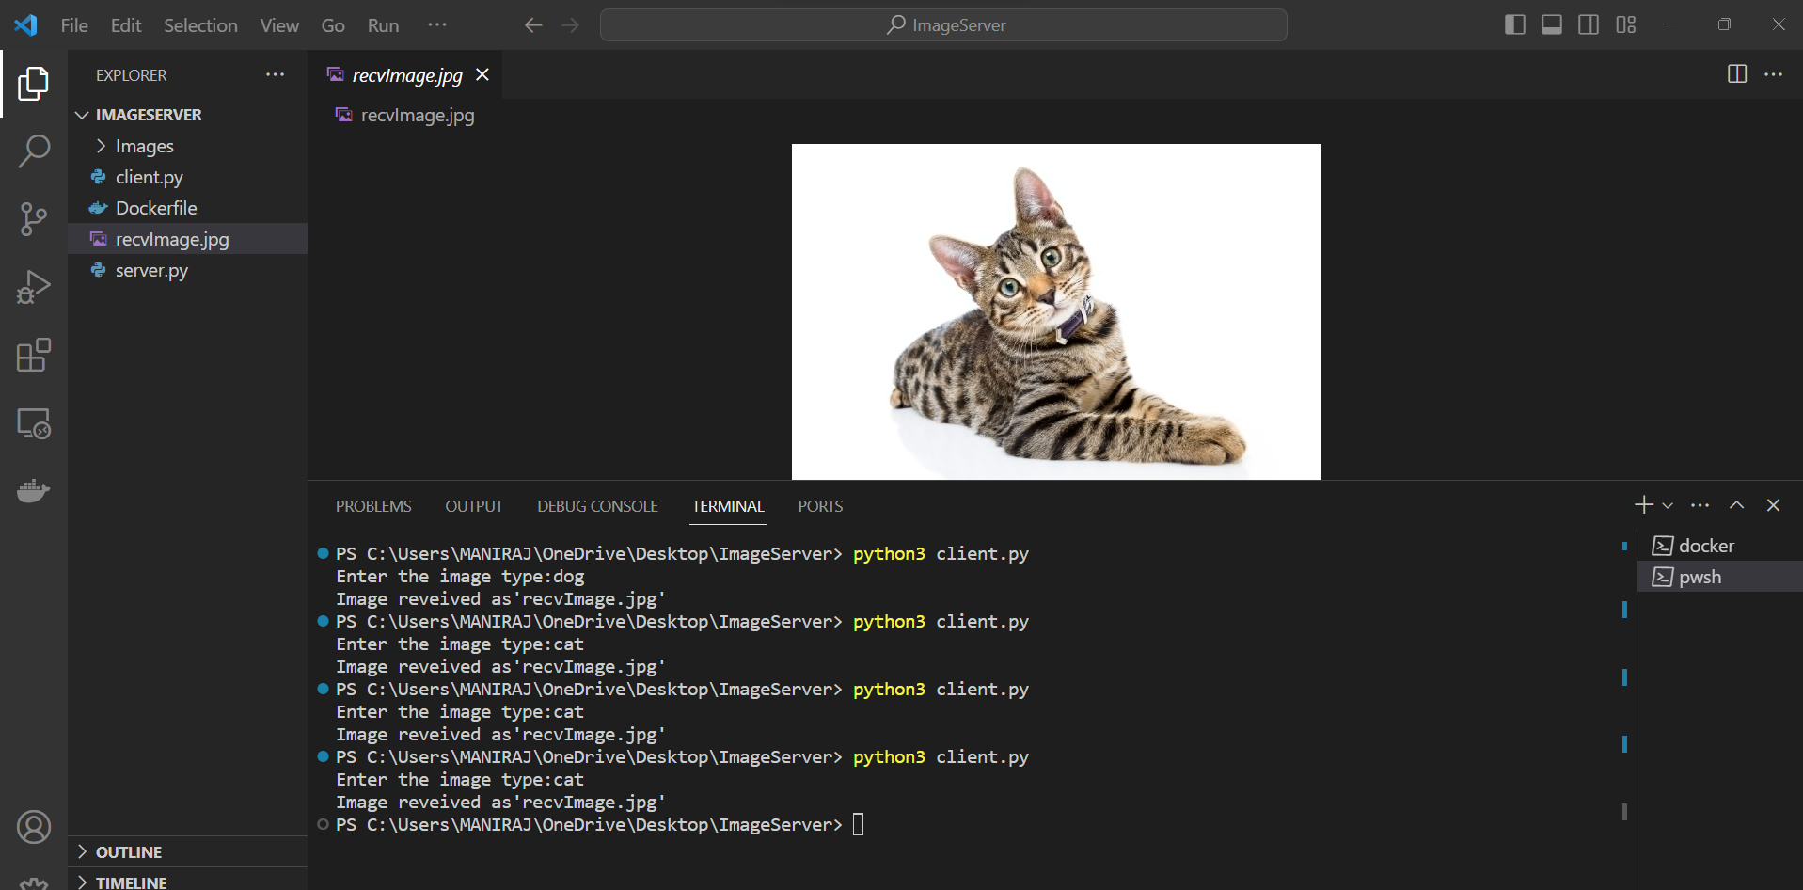

**Test case 3**

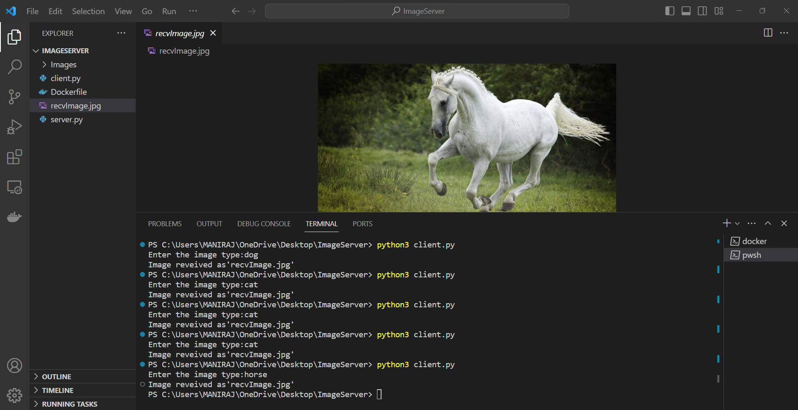

**Test case 4**

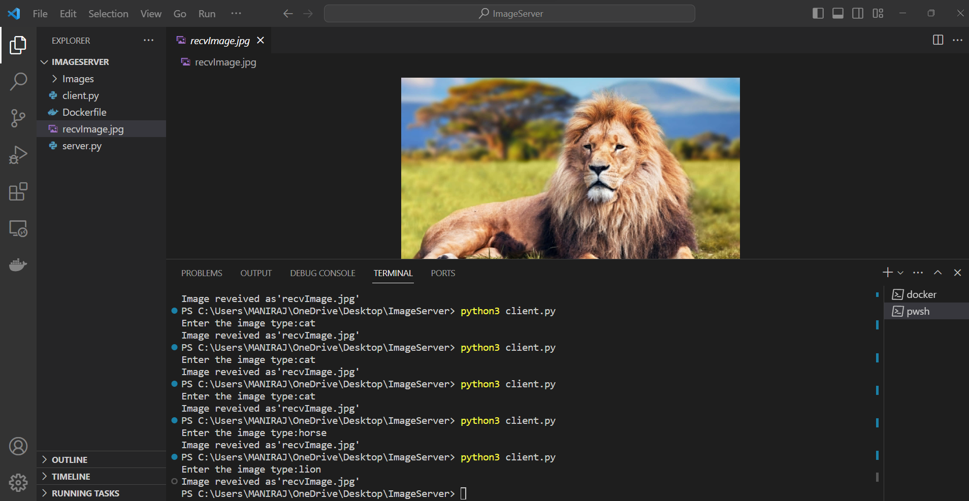

**Test case 5**

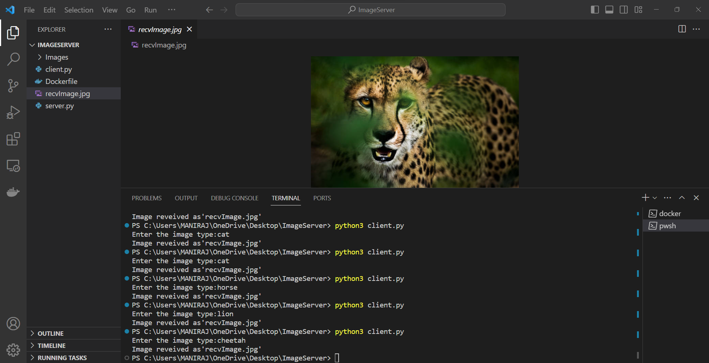

References:

<https://docs.docker.com/language/python/>

<https://docs.docker.com/language/java/>

<https://grpc.io/docs/languages/python/quickstart/>

<https://grpc.io/docs/languages/java/quickstart/>

<https://docs.docker.com/engine/reference/commandline/build/>

<https://www.youtube.com/watch?v=gbrPMv_GuQY>

<https://docs.docker.com/engine/reference/commandline/run/>